INTRODUCTION

With the rapid advancements in the field of information technology, the amount of information available has increased tremendously. News articles constitute the largest available portion of factual information about events happening in the world. Corporate news constitutes a major chunk of these news articles. Such news is related to a wide range of events such as acquisitions, mergers, Shares/stock performances, product launches, executive changes, projects, legal proceedings, among others.

Now this is a huge amount of information and can be spread on the internet in a haphazard way. However, once organized in a systematic manner, this pool of information becomes potentially a very good resource for various tasks like analyzing the market trends of companies, helping in corporate decision making, tracking the activities of rival companies etc.

This project describes a way of identifying corporate news from a collection of news articles and then pairing the news with the organization/company which is being talked about in the article. The model is capable of differentiating the main organization (which is the focus of the news) from other organizations which find mention.

The entire approach is dynamic in nature with respect to detection of company names as no lists containing company names have been used. The system remains unaffected if new companies are formed or existing ones are merged.

The model uses a machine learning approach to do this task. We extract a set of features from the news and use them to train a SVM classifier. This classifier is then used to classify test data. One advantage of our approach described below is that it only requires a

very small amount of un-annotated training data. We trained the model with 250 true positive news articles and 250 false negative articles.

Background
Client of this project need a Info Miner System that deals with Online Browsing, Buffering of different news, Comparing different news etc.

Objectives
The main objective of this project is to design software for any Info Miner to keep track of browsing, information, online data entity, and Back office functions into one web-based application. And also it consists of the information about the competitors.

Purpose, Scope and Achievements
Purpose
With the rapid advancements in the field of information technology, the amount of information available has increased tremendously. News articles constitute the largest available portion of factual information about events happening in the world. Corporate news constitutes a major chunk of these news articles. Such news is related to a wide range of events such as acquisitions, mergers, Shares/stock performances, product launches, executive changes, projects, legal proceedings, among others. Now this is a huge amount of information and can be spread on the internet in a haphazard way. However, once organized in a systematic manner, this pool of information becomes potentially a very good resource for various tasks like analyzing the market trends of companies, helping in corporate decision making, tracking the activities of rival companies etc.

This project finds a way of identifying corporate news from a collection of news articles and then pairing the news with the organization/company which is being talked about in

the article. The model is capable of differentiating the main organization (which is the focus of the news) from other organizations which find mention.

Achievements
This project gives us an opportunity of improving our designing, coding, analyzing and testing skills.

Innovation

Our project combines the power of web as an information warehouse and the intelligence of machine learning with the techniques of Natural Language Processing to automate a task which otherwise consumes a lot of resources like time, memory and most important of all humans. We eliminate the presence of humans in order to achieve the task by making it fully automatic. The design is unique in the sense that our entire approach is dynamic in nature with respect to detection of company names as no lists containing company names have been used. The system remains unaffected if new companies are formed or existing ones are merged. Current approach employed by various companies is basic keyword search in the news articles which gives tones of irrelevant results. Our approach solves this problem and the results are promising in reducing the number of irrelevant results to a great extent.

Practical Application
In this era of information overload, we require intelligent systems that can read, interpret and analyze information themselves. Our project is one which fulfills all these parameters. All companies need to be aware of their rivals as to what all things they are involved in, where on the web are they being talked about etc. Our project provides them with all they need to know about all other companies. There are various companies who employ people (Content Team) to manually tag news and classify them after reading each and every news article. We replace their entire content team with our software. Companies involved with

Sales processes and Business Intelligence like SalesForce, InsideView, SugarCRM, etc all need to know information about all other companies in order to give their clients accurate information. Our system solves all their problems in this domain.

Information Extraction

Introduction

Information extraction (IE) is a type of information retrieval whose goal is to automatically extract structured information from unstructured machine-readable documents. Information extraction differs from information retrieval, in that the focus is not upon finding documents but upon finding useful information inside documents. Typically, texts in an electronic document feed are examined to see if they contain certain target terms, and therefore merit further analysis.
A broad goal of IE is to allow computation to be done on the previously unstructured data. A more specific goal is to allow logical reasoning to draw inferences based on the logical content of the input data. Structured data is semantically well-defined data from a chosen target domain, interpreted with respect to category and context.
An intelligent agent monitoring a news data feed requires IE to transform unstructured data into something that can be reasoned with. A typical application of IE is to scan a set of documents written in a natural language and populate a database with the information extracted.

Conditional random fields (CRFs) are a class of statistical modelling method often applied in pattern recognition and machine learning, where they are used for structured prediction. Whereas an ordinary classifier predicts a label for a single sample without regard to "neighboring" samples, a CRF can take context into account; e.g., the linear chain CRF popular in natural language processing predicts sequences of labels for sequences of input samples.
CRFs are a type of discriminative undirected probabilistic graphical model. It is used to encode known relationships between observations and construct consistent interpretations. It is often used for labeling or parsing of sequential data, such as natural language text or biological sequences and in computer vision. Specifically, CRFs find applications in shallow parsing, named entity recognition and gene finding, among other tasks, being an alternative to the related hidden Markov models. In computer vision, CRFs are often used for object recognition and image segmentation.

Web Crawler

A web crawler is a relatively simple automated program, or script, that methodically scans or "crawls" through Internet pages to create an index of the data it's looking for.

Alternative names for a web crawler include web spider, web robot, bot, crawler, and automatic indexer.
A Web crawler is one type of bot, or software agent. In general, it starts with a list of URLs to visit, called the seeds. As the crawler visits these URLs, it identifies all the hyperlinks in the page and adds them to the list of URLs to visit, called the crawl frontier. URLs from the frontier are recursively visited according to a set of policies.
Linguists may use a web crawler to perform a textual analysis; that is, they may comb the Internet to determine what words are commonly used today. Market researchers may use a web crawler to determine and assess trends in a given market. There are numerous nefarious uses of web crawlers as well. In the end, a web crawler may be used by anyone seeking to collect information out on the Internet.
Web crawling is an important method for collecting data on, and keeping up with, the rapidly expanding Internet. A vast number of web pages are continually being added every day, and information is constantly changing. A web crawler is a way for the search engines and other users to regularly ensure that their databases are up to date.

Examples of Web Crawlers

Some of the web crawlers include:

- GoogleBot
- Yahoo! Slurp
- Msnbot
- Nutch
- YaCy
- Paavuk

Related Work

Much work has been done on text classification.(Barak, 2009; Sebastiani,2002) There have been earlier attempts (Research on Sports Game News Information Extraction, Yonggui YANG,et al) However, they had focused mainly on information extraction and not classification.
Earlier attempts on web news classification (Krishnlal et al, 2010) concentrated mainly on classification according to the domain of the news articles. Not much work has been done in the field of corporate news-company pairing. This project tries to address a more general problem of detecting the main organization being talked about in the articles.
Sentiment analysis in computational linguistics has focused on examining what textual features contribute to affective content of text and automatically detecting these features to derive a sentiment metric for a word, sentence or whole text.
Niederhoffer (1971) after classifying New York Times headlines into 19 categories evaluated how the markets react to good and bad news. Davis et al (2006) investigate the effects of optimistic or pessimistic language used in financial press releases on future firm performance. Sumbaly et al(2009) used k gram models to detect sentiment in large news datasets. Devitt(2007) improves upon and Melville(2009) have done work on sentiment analysis of web blogs.

TECHNIQUES USED

Nutch Crawler

A Nutch is open source web-search software. It builds on Lucene and Solr, adding web-specifics, such as a crawler, a link-graph database, parsers for HTML and other document formats, etc. Nutch can run on a single machine, but gains a lot of its strength from running in a Hadoop cluster.
It is coded completely in the Java programming language, but data is written in language-independent formats. Nutch has a highly modular architecture allowing developers to create plugins for the following activities: media-type parsing, data retrieval, querying and clustering.
Nutch graduated from the Apache Incubator and was a subproject of Lucene. As of April, 2010, Nutch is considered an independent, top level project of the Apache Software Foundation.

Some of the advantages of Nutch, when compared to a simple Fetcher
- highly scalable and relatively feature rich crawler
- features like politeness which obeys robots.txt rules
- robust and scalable - you can run Nutch on a cluster of 100 machines
- quality - you can bias the crawling to fetch “important” pages first
Nutch is built on top of Lucene, which is an API for text
indexing and searching. A common question is: "Should I use Lucene
or Nutch?" The simple answer is that you should use Lucene if you
don't need a web crawler. A common scenario is that you have a web
front end to a database that you want to make searchable. The best
way to do this is to index the data directly from the database
using the Lucene API, and then write code to do searches against the
index, again using Lucene. Erik Hatcher and Otis Gospodnetić's
Lucene in
Action gives all of the details. Nutch is a better fit for sites
where you don't have direct access to the underlying data, or it
comes from disparate sources.

Some Nutch Commands
crawl one-step crawler for intranets
readdb read / dump crawl db
convdb convert crawl db from pre-0.9 format
mergedb merge crawldb-s, with optional filtering
readlinkdb read / dump link db
inject inject new urls into the database
generate generate new segments to fetch from crawl db
freegen generate new segments to fetch from text files
fetch fetch a segment's pages
parse parse a segment's pages
readseg read / dump segment data
mergesegs merge several segments, with optional filtering and slicing

Machine Learning


Introduction

Machine Learning is the study of computer algorithms that improve automatically through experience. A major focus of machine learning research is to automatically learn to recognize complex patterns and make intelligent decisions based on data; the difficulty lies in the fact that the set of all possible behaviors given all possible inputs is too complex to describe generally in programming languages, so that in effect programs must automatically describe programs.
Machine learning is the science of getting computers to act without being explicitly programmed. In the past decades, Machine learning has given us self -driven cars, practical speech recognition, effective web search and a variety of the human genuine.
Tom M. Mitchell provided a widely quoted definition: A computer program is said to learn from experience E with respect to some class of tasks T and performance measure P, if its performance at tasks in T, as measured by P, improves with experience E.
These three terms (ML, knowledge discovery and data mining) are commonly confused, as they often employ the same methods and overlap strongly. They can be roughly separated as follows:

- Machine learning focuses on the prediction, based on known properties learned from the training data
- Data mining (which is the analysis step of Knowledge Discovery in Databases) focuses on the discovery of (previously) unknown properties on the data
However, these two areas overlap in many ways: data mining uses many machine learning methods, but often with a slightly different goal in mind. On the other hand, machine learning also employs data mining methods as "unsupervised learning" or as a preprocessing step to improve learner accuracy. Much of the confusion between these two research communities (which do often have separate conferences and separate journals, ECML PKDD being a major exception) comes from the basic assumptions they work with: in machine learning, the performance is usually evaluated with respect to the ability to reproduce known knowledge, while in KDD the key task is the discovery of previously unknown knowledge. Evaluated with respect to known knowledge, an uninformed (unsupervised) method will easily be outperformed by supervised methods, while in a typical KDD task, supervised methods cannot be used due to the unavailability of training data.

Certain examples- Facebook, Medical records,
Applications can’t program by hand.
E.g., Autonomous helicopter, handwriting recognition, most of Natural Language Processing (NLP), Computer Vision. ,etc.

Algorithm Types

Machine learning algorithms are organized into taxonomy, based on the desired outcome of the algorithm.

- Supervised learning generates a function that maps inputs to desired outputs (also called labels, because they are often provided by human experts labeling the training examples). For example, in a classification problem, the learner approximates a function mapping a vector into classes by looking at input-output examples of the function.
- Unsupervised learning models a set of inputs, like clustering.
- Semi-supervised learning combines both labeled and unlabeled examples to generate an appropriate function or classifier.
- Reinforcement learning learns how to act given an observation of the world. Every action has some impact in the environment, and the environment provides feedback in the form of rewards that guides the learning algorithm.
- Transduction or transductive inference, tries to predict new outputs on specific and fixed (test) cases from observed, specific (training) cases.
- Learning to learn learns its own inductive bias based on previous experience.

Approaches to Machine Learning

Some of the widely used approaches used in Machine Learning include:

- Decision tree learning uses a decision tree as a predictive model which maps observations about an item to conclusions about the item's target value.
- Association rule learning is a method for discovering interesting relations between variables in large databases.
- Artificial neural networks (ANN) learning algorithm, usually called "neural network" (NN), is a learning algorithm that is inspired by the structure and functional aspects of biological neural networks. Computations are structured in terms of an interconnected group of artificial neurons, processing information using a connectionist approach to computation. Modern neural networks are non-linear statistical data modeling tools. They are usually used to model complex relationships between inputs and outputs, to find patterns in data, or to capture the statistical structure in an unknown joint probability distribution between observed variables.
- Genetic programming (GP) is an evolutionary algorithm-based methodology inspired by biological evolution to find computer programs that perform a user-defined task. It is a specialization of genetic algorithms (GA) where each individual is a computer program. It is a machine learning technique used to optimize a population of computer programs according to a fitness landscape determined by a program's ability to perform a given computational task
- Clustering Cluster analysis is the assignment of a set of observations into subsets (called clusters) so that observations in the same cluster are similar in some sense, while observations in different clusters are dissimilar. The variety of clustering techniques make different assumptions on the structure of the data, often defined by some similarity metric and evaluated for example by internal compactness (similarity between members of the same cluster) and separation between different clusters. Other methods are based on estimated density and graph connectivity. Clustering is a method of unsupervised learning, and a common technique for statistical data analysis.
- Bayesian networks A Bayesian network, belief network or directed acyclic graphical model is a probabilistic graphical model that represents a set of random variables and their conditional independencies via a directed acyclic graph (DAG). For example, a Bayesian network could represent the probabilistic relationships between diseases and symptoms. Given symptoms, the network can be used to compute the probabilities of the presence of various diseases. Efficient algorithms exist that perform inference and learning.
- Reinforcement learning Reinforcement learning is concerned with how an agent ought to take actions in an environment so as to maximize some notion of long-term reward. Reinforcement learning algorithms attempt to find a policy that maps states of the world to the actions the agent ought to take in those states. Reinforcement learning differs from the supervised learning problem in that correct input/output pairs are never presented, nor sub-optimal actions explicitly corrected.

Support Vector Machines

A Support Vector Machine (SVM) performs classification by constructing an N-dimensional hyper plane that optimally separates the data into two categories. SVM models are closely related to neural networks.

A support vector machine (SVM) is a concept in statistics and computer science for a set of related supervised learning methods that analyze data and recognize patterns, used for classification and regression analysis. The standard SVM takes a set of input data and predicts, for each given input, which of two possible classes forms the input, making the SVM a non-probabilistic binary linear classifier. Given a set of training examples, each marked as belonging to one of two categories, an SVM training algorithm builds a model that assigns new examples into one category or the other. An SVM model is a representation of the examples as points in space, mapped so that the examples of the separate categories are divided by a clear gap that is as wide as possible. New examples are then mapped into that same space and predicted to belong to a category based on which side of the gap they fall on.

Support vector machines (SVMs) are a set of related supervised learning methods used for classification and regression. In simple words, given a set of training examples, each marked as belonging to one of two categories, an SVM training algorithm builds a model that predicts whether a new example falls into one category or the other.

Support Vector Machine (SVM) models are a close cousin to classical multilayer perceptron neural networks. Using a kernel function, SVM’s are an alternative training method for polynomial, radial basis function and multi-layer perceptron classifiers in which the weights of the network are found by solving a quadratic programming problem with linear constraints, rather than by solving a non-convex, unconstrained minimization problem as in standard neural network training.

Support Vector Machine (SVM) models are a close cousin to classical multilayer perceptron neural networks. Using a kernel function, SVM’s are an alternative training method for polynomial, radial basis function and multi-layer perceptron classifiers in which the weights of the network are found by solving a quadratic programming problem with linear constraints, rather than by solving a non-convex, unconstrained minimization problem as in standard neural network training.

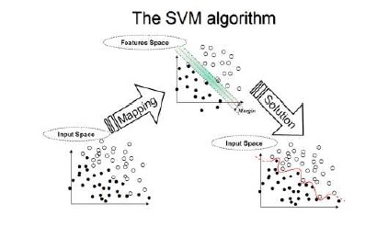

A Two Dimensional Example
The accuracy of an SVM model is largely dependent on the selection of the kernel parameters such as C, Gamma, P, etc. A grid search tries values of each parameter across the specified search range using geometric steps. A pattern search (also known as a “compass search” or a “line search”) starts at the center of the search range and makes trial steps in each direction for each parameter. If the fit of the model improves, the search center moves to the new point and the process is repeated. If no improvement is found, the step size is reduced and the search is tried again. The pattern search stops when the search step size is reduced to a specified tolerance.

Multiclass SVM

Multiclass SVM aims to assign labels to instances by using support vector machines, where the labels are drawn from a finite set of several elements.
The dominant approach for doing so is to reduce the single multiclass problem into multiple binary classification problems. Common methods for such reduction include:
- Building binary classifiers which distinguish between (i) one of the labels and the rest (one-versus-all) or (ii) between every pair of classes (one-versus-one). Classification of new instances for the one-versus-all case is done by a winner-takes-all strategy, in which the classifier with the highest output function assigns the class (it is important that the output functions be calibrated to produce comparable scores). For the one-versus-one approach, classification is done by a max-wins voting strategy, in which every classifier assigns the instance to one of the two classes, then the vote for the assigned class is increased by one vote, and finally the class with the most votes determines the instance classification.
- Directed Acyclic Graph SVM (DAGSVM)
- error-correcting output codes
Crammer and Singer proposed a multiclass SVM method which casts the multiclass classification problem into a single optimization problem, rather than decomposing it into multiple binary classification problems.

Logistic Regression

In statistics, logistic regression (sometimes called the logistic model or logit model) is a type of regression analysis used for predicting the outcome of a binary dependent variable (a variable which can take only two possible outcomes, e.g. "yes" vs. "no" or "success" vs. "failure") based on one or more predictor variables. Logistic regression attempts to model the probability of a "yes/success" outcome using a linear function of the predictors. Specifically, the log-odds of success (the logit of the probability) is fit to the predictors using linear regression. Logistic regression is one type of discrete choice model, which in general predict categorical dependent variables — either binary or multi-way.
Like other forms of regression analysis, logistic regression makes use of one or more predictor variables that may be either continuous or categorical. Also, like other linear regression models, the expected value (average value) of the response variable is fit to the predictors — the expected value of a Bernoulli distribution is simply the probability of success. Unlike ordinary linear regression, however, logistic regression is used for predicting binary outcomes (Bernoulli trials) rather than continuous outcomes, and models a transformation of the expected value as a linear function of the predictors, rather than the expected value itself.
For example, logistic regression might be used to predict whether a patient has a given disease (e.g. diabetes), based on observed characteristics of the patient (age, gender, body mass index, results of various blood tests, etc.). Another example might be to predict whether a voter will vote Democratic or Republican, based on age, income, gender, race, state of residence, votes in previous elections, etc. Logistic regression is used extensively in numerous disciplines: the medical and social sciences fields, natural language processing, marketing applications such as prediction of a customer's propensity to purchase a product or cease a subscription, etc.

Extensions in Logistic Regression
There are large numbers of extensions:
- Multinomial logistic regression (or multinomial logit) handles the case of a multi-way categorical dependent variable (with unordered values, also called "classification"). Note that the general case of having dependent variables with more than two values is termed polytomous regression.
- Ordered logistic regression (or ordered logit) handles ordinal dependent variables (ordered values).
- Mixed logit is an extension of multinomial logit that allows for correlations among the choices of the dependent variable.
- An extension of the logistic model to sets of interdependent variables is the conditional random field.

Model Accuracy

A way to test for errors in models created by step-wise regression is to not rely on the model's F-statistic, significance, or multiple-r, but instead assess the model against a set of data that was not used to create the model.^{[4]} The class of techniques is called cross-validation.
Accuracy is measured as correctly classified records in the holdout sample. There are four possible classifications:
- prediction of 0 when the holdout sample has a 0 (True Negative/TN)
- prediction of 0 when the holdout sample has a 1 (False Negative/FN)
- prediction of 1 when the holdout sample has a 0 (False Positive/FP)
- prediction of 1 when the holdout sample has a 1 (True Positive/TP)
These classifications are used to measure Precision and Recall:
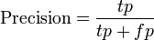

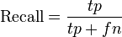
The percent of correctly classified observations in the holdout sample is referred to the assessed model accuracy. Additional accuracy can be expressed as the model's ability to correctly classify 0, or the ability to correctly classify 1 in the holdout dataset. The holdout model assessment method is particularly valuable when data are collected in different settings (e.g., at different times or places) or when models are assumed to be generalizable.

AdaBoost

AdaBoost, short for Adaptive Boosting, is a machine learning algorithm, formulated by Yoav Freund and Robert Schapire. It is a meta-algorithm, and can be used in conjunction with many other learning algorithms to improve their performance. AdaBoost is adaptive in the sense that subsequent classifiers built are tweaked in favor of those instances misclassified by previous classifiers. AdaBoost is sensitive to noisy data and outliers. In some problems, however, it can be less susceptible to the overfitting problem than most learning algorithms. The classifiers it uses can be weak (i.e., display a substantial error rate), but as long as their performance is not random (resulting in an error rate of 0.5 for binary classification), they will improve the final model. Even classifiers with an error rate higher than would be expected from a random classifier will be useful, since they will have negative coefficients in the final linear combination of classifiers and hence behave like their inverses.
AdaBoost generates and calls a new weak classifier in each of a series of rounds . For each call, a distribution of weights is updated that indicates the importance of examples in the data set for the classification. On each round, the weights of each incorrectly classified example are increased, and the weights of each correctly classified example are decreased, so the new classifier focuses on the examples which have so far eluded correct classification.

Naïve Bayes Classifier

A naive Bayes classifier is a simple probabilistic classifier based on applying Bayes' theorem with strong (naive) independence assumptions. A more descriptive term for the underlying probability model would be "independent feature model".

Introduction

In simple terms, a naive Bayes classifier assumes that the presence (or absence) of a particular feature of a class is unrelated to the presence (or absence) of any other feature, given the class variable. For example, a fruit may be considered to be an apple if it is red, round, and about 4" in diameter. Even if these features depend on each other or upon the existence of the other features, a naive Bayes classifier considers all of these properties to independently contribute to the probability that this fruit is an apple.
Depending on the precise nature of the probability model, naive Bayes classifiers can be trained very efficiently in a supervised learning setting. In many practical applications, parameter estimation for naive Bayes models uses the method of maximum likelihood; in other words, one can work with the naive Bayes model without believing in Bayesian probability or using any Bayesian methods.
In spite of their naive design and apparently over-simplified assumptions, naive Bayes classifiers have worked quite well in many complex real-world situations. In 2004, analysis of the Bayesian classification problem has shown that there are some theoretical reasons for the apparently unreasonable efficacy of naive Bayes classifiers. Still, a comprehensive comparison with other classification methods in 2006 showed that Bayes classification is outperformed by more current approaches, such as boosted trees or random forests.
An advantage of the naive Bayes classifier is that it only requires a small amount of training data to estimate the parameters (means and variances of the variables) necessary for classification. Because independent variables are assumed, only the variances of the variables for each class need to be determined and not the entire covariance matrix.
Parameter Estimation
All model parameters (i.e., class priors and feature probability distributions) can be approximated with relative frequencies from the training set. These are maximum likelihood estimates of the probabilities. A class' prior may be calculated by assuming equiprobable classes (i.e., priors = 1 / (number of classes)), or by calculating an estimate for the class probability from the training set (i.e., (prior for a given class) = (number of samples in the class) / (total number of samples)). To estimate the parameters for a feature's distribution, one must assume a distribution or generate nonparametric models for the features from the training set. For example, suppose the training data contains a continuous attribute, . We first segment the data by the class, and then compute the mean and variance of in each class. Let be the mean of the values in associated with class c, and let be the variance of the values in associated with class c. Then, the probability of some value given a class, , can be computed by plugging into the equation for a Normal distribution parameterized by and . That is,
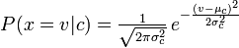
Another common technique for handling continuous values is to use binning to discretize the values. In general, the distribution method is a better choice if there is a small amount of training data, or if the precise distribution of the data is known. The discretization method tends to do better if there is a large amount of training data because it will learn to fit the distribution of the data. Since naive Bayes is typically used when a large amount of data is available (as more computationally expensive models can generally achieve better accuracy), the discretization method is generally preferred over the distribution method.

F1 Score
In statistics, the F₁ score (also F-score or F-measure) is a measure of a test's accuracy. It considers both the precision p and the recall r of the test to compute the score: p is the number of correct results divided by the number of all returned results and r is the number of correct results divided by the number of results that should have been returned. The F₁ score can be interpreted as a weighted average of the precision and recall, where an F₁ score reaches its best value at 1 and worst score at 0.
The traditional F-measure or balanced F-score (F₁ score) is the harmonic mean of precision and recall:
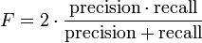.
The general formula for positive real β is:
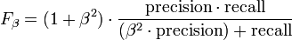.
The formula in terms of Type I and type II errors:
The F-measure was derived so that "measures the effectiveness of retrieval with respect to a user who attaches β times as much importance to recall as precision" .
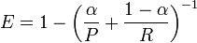.
Their relationship is where 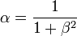.

Natural Language Processing

Introduction

Natural Language processing (NLP) is a field of computer science and linguistics concerned with the interactions between computers and human (natural) languages. In theory, natural-language processing is a very attractive method of human-computer interaction.

It is a theoretically motivated range of computational techniques for analyzing and representing naturally occurring texts at one or more levels of linguistic analysis for the purpose of achieving human-like language processing for a range of tasks or applications.
‘Human-like language processing’ reveals that NLP is considered a discipline within Artificial Intelligence (AI). And while the full lineage of NLP does depend on a number of other disciplines, since NLP strives for human-like performance, it is appropriate to consider it an AI discipline.
Consider the task of part of speech tagging, i.e. determining the correct part of speech of each word in a given sentence, typically one that has never been seen before. A typical machine-learning-based implementation of a part of speech tagger proceeds in two steps, a training step and an evaluation step. The first step — the training step — makes use of a corpus of training data, which consists of a large number of sentences, each of which has the correct part of speech attached to each word. (An example of such a corpus in common use is the Penn Treebank. This includes (among other things) a set of 500 texts from the Brown Corpus, containing examples of various genres of text, and 2500 articles from the Wall Street Journal.) This corpus is analyzed and a learning model is generated from it, consisting of automatically created rules for determining the part of speech for a word in a sentence, typically based on the nature of the word in question, the nature of surrounding words, and the

most likely part of speech for those surrounding words. The model that is generated is typically the best model that can be found that simultaneously meets two conflicting objectives: To perform as well as possible on the training data, and to be as simple as possible (so that the model avoids overfitting the training data, i.e. so that it generalizes as well as possible to new data rather than only succeeding on sentences that have already been seen). In the second step (the evaluation step), the model that has been learned is used to process new sentences. An important part of the development of any learning algorithm is testing the model that has been learned on new, previously unseen data. It is critical that the data used for testing is not the same as the data used for training; otherwise, the testing accuracy will be unrealistically high.

Sub problems in NLP

Some of the sub problems included in NLP include the following:

1) Part-of-speech tagging- eg- Colorless_ADJ green_ADJ ideas_NN sleep_VB furiously_ADJ.
2) Text segmentation
3) Word sense disambiguation- eg- I need new batteries for my mouse.
4) Speech acts and plans
5) Spam Detection- eg- Buy c1othes for Mary.
6) Summarization- eg- The Dow Jones is up. The S&P500 jumped. Ans- Economy is good.

POS Tagger

A Part-Of-Speech Tagger (POS Tagger) is a piece of software that reads text in some language and assigns parts of speech to each word (and other token), such as noun, verb, adjective, etc., although generally computational applications use more fine-grained POS tags like 'noun-plural'.

In corpus linguistics, part-of-speech tagging (POS tagging or POST), also called grammatical tagging or word-category disambiguation, is the process of marking up a word in a text (corpus) as corresponding to a particular part of speech, based on both its definition, as well as its context—i.e. relationship with adjacent and related words in a phrase, sentence, or paragraph. A simplified form of this is commonly taught to school-age children, in the identification of words as nouns, verbs, adjectives, adverbs, etc.
It is the process of marking up the words in a text (corpus) as corresponding to a particular part of speech, based on both its definition, as well as its context —i.e. Relationship with adjacent and related words in a phrase, sentence, or paragraph. A simplified form of this is commonly taught to school-age children, in the identification of words as nouns, verbs, adjectives, adverbs, etc.

Native speakers of a language perform grammatical and semantic analysis innately, and thus trained linguists can identify the grammatical parts of speech to various fine degrees depending on the tagging system. Schools commonly teach that there are 9 parts of speech in English: noun, verb, article, adjective, preposition, pronoun, adverb, conjunction, and interjection.

In part-of-speech tagging by computer, it is typical to distinguish from 50 to 150 separate parts of speech for English, for example, NN for singular common nouns, NNS for plural common nouns, and NP for singular proper.
It is, however, also possible to bootstrap using "unsupervised" tagging. Unsupervised tagging techniques use an untagged corpus for their training data and produce the

tagset by induction. That is, they observe patterns in word use, and derive part-of-speech categories themselves. For example, statistics readily reveal that "the", "a", and "an" occur in similar contexts, while "eat" occurs in very different ones. With sufficient iteration, similarities classes of words emerge that are remarkably similar to those human linguists would expect; and the differences themselves sometimes suggest valuable new insights.
These two categories can be further subdivided into rule-based, stochastic, and neural approaches.

Part-of-speech tagging is harder than just having a list of words and their parts of speech, because some words can represent more than one part of speech at different times, and because some parts of speech are complex or unspoken. This is not rare—in natural languages (as opposed to many artificial languages), a large percentage of word-forms are ambiguous. For example, even "dogs", which is usually thought of as just a plural noun, can also be a verb:
The sailor dogs the barmaid.
Performing grammatical tagging will indicate that "dogs" is a verb, and not the more common plural noun, since one of the words must be the main verb, and the noun reading is less likely following "sailor" (sailor !→ dogs). Semantic analysis can then extrapolate that "sailor" and "barmaid" implicate "dogs" as 1) in the nautical context (sailor→<verb>←barmaid) and 2) an action applied to the object "barmaid" ([subject] dogs→barmaid). In this context, "dogs" is a nautical term meaning "fastens (a watertight barmaid) securely; applies a dog to".
"Dogged", on the other hand, can be either an adjective or a past-tense verb. Just which parts of speech a word can represent varies greatly.

I used the Stanford POS Tagger which takes in an input file as text and returns a tagged text file.
- Words often have more than one POS: back
  - The back door = JJ
  - On my back = NN
  - Win the voters back = RB
  - Promised to back the bill = VB
INPUT FILE:
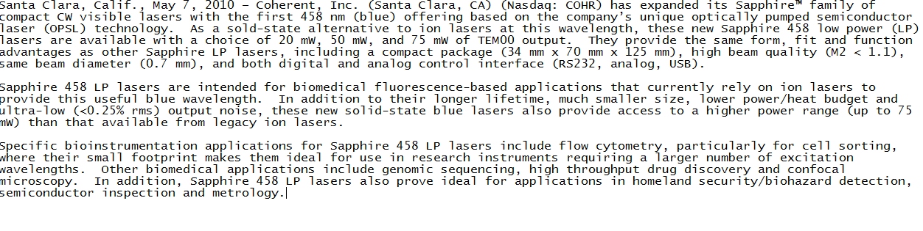
OUTPUT Obtained:

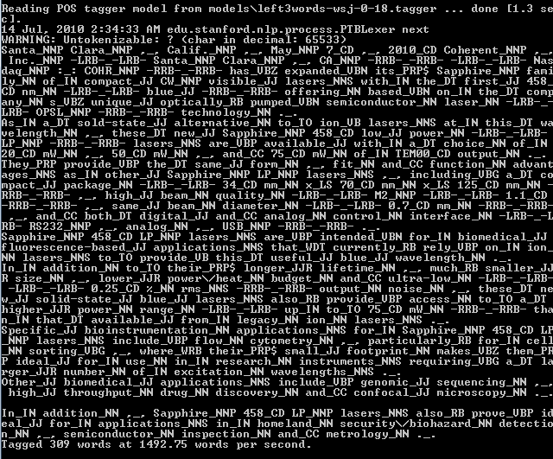

Named Entity Recognition

Named Entity Recognition (NER) labels sequences of words in a text which are the names of things, such as person and company names, or gene and protein names.

It is a subtask of information extraction that seeks to locate and classify atomic elements in text into predefined categories such as the names of persons, organizations, locations, expressions of times, quantities, monetary values, percentages, etc.

Named-entity recognition (NER) (also known as entity identification and entity extraction) is a subtask of information extraction that seeks to locate and classify atomic elements in text into predefined categories such as the names of persons, organizations, locations, expressions of times, quantities, monetary values, percentages, etc.
Most research on NER systems has been structured as taking an unannotated block of text, such as this one:
Jim bought 300 shares of Acme Corp. in 2006.
And producing an annotated block of text, such as this one:
<ENAMEX TYPE="PERSON">Jim</ENAMEX>bought<NUMEX TYPE="QUANTITY">300</NUMEX>shares of<ENAMEX TYPE="ORGANIZATION">Acme Corp.</ENAMEX> in <TIMEX TYPE="DATE">2006</TIMEX>.

In the expression named entity, the word named restricts the task to those entities for which one or many rigid designators, stands for the referent. For instance, the automotive company created by Henry Ford in 1903 is referred to as Ford or Ford Motor Company. Rigid designators include proper names as well as certain natural kind terms like biological species and substances.

Stanford Named Entity Recognizer

I used the Stanford NER to tag names of Persons, Organizations and Location. CRF Classifier is a Java implementation of Stanford Named Entity Recognizer. The software provides a general (arbitrary order) implementation of linear chain Conditional Random Field (CRF) sequence models, coupled with well-engineered feature extractors for Named Entity Recognition.

Eg- Einstein_PER met with UN_ORG officials in Princeton_LOC.

News-Company Pairing

I made few rules to ensure that the news is paired to the correct company. These rules include:

1) POS–NNP pair- If this is present then the product of the company is being talked about.
2) PRP$ - NNP pair- This classifies anything related to the company being talked about.
3) NNP – NNS pair- This refers to the company names which are not identified by the NER Tagger.

These rules are applied to the output of the POS Tagger.

The Java program implementing these rules is given below:

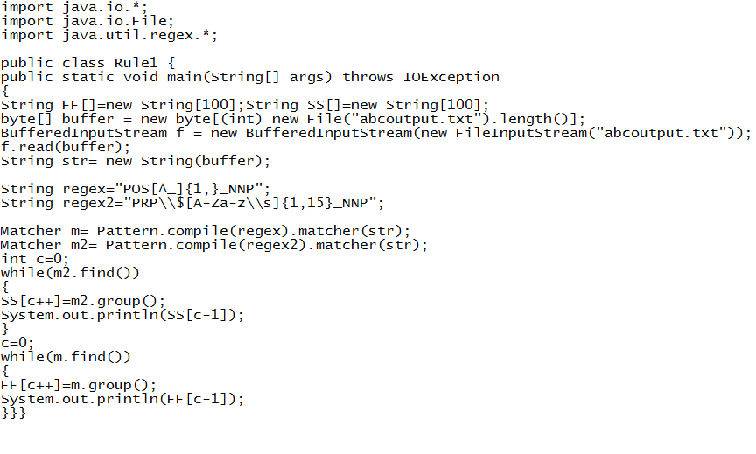

The sample input to the program is the output of the POS Tagger:

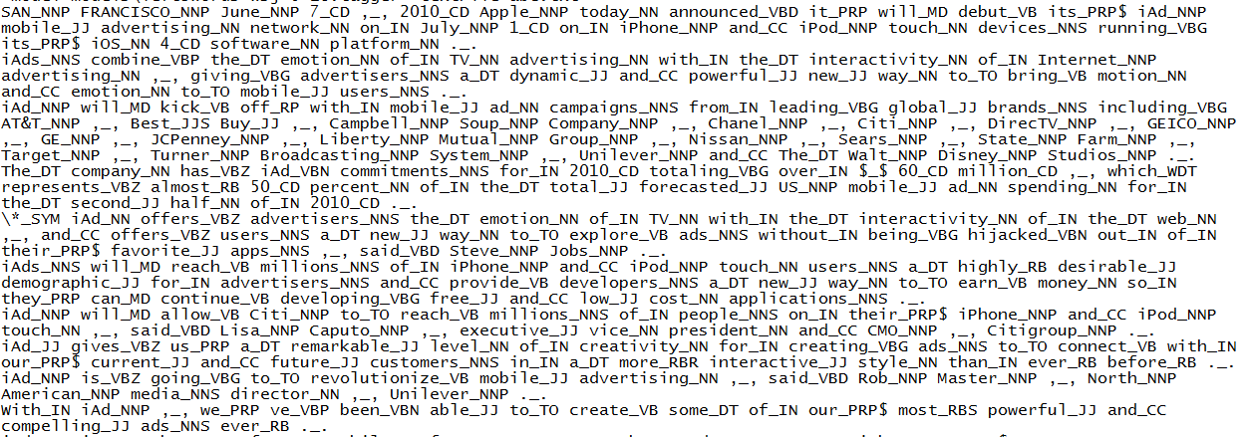

The Output got was:

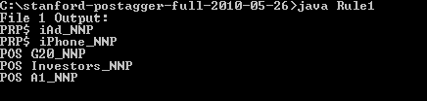

2. SYSTEM REQUIREMENT SPECIFICATION
Existing system
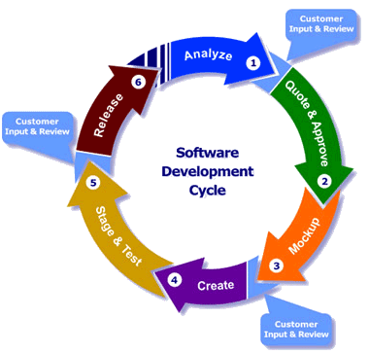
.
Our project is divided into various modules including automatically extracting news articles from the web, classifying these news articles as corporate or non-corporate and finally using Natural language processing tools to find the name of the organization which is being talked about in the news article. We use Nutch crawler to crawl the web searching for news articles. This crawler gives us tens of thousands of news articles generated daily on the web. After the news articles have been collected we perform various news pre-processing techniques in order to speed up our system. Next we use Named Entity Recognition to extract organization names in the news
articles followed by keyword frequency detection. We then scan the news for finding if any of the company products are being talked about in the news, followed by executive detection. We then use Part Of Speech Tagging and other NLP rules developed by us to generate a set of features which will be used for training our model which will ultimately classify fresh news articles. A classification task usually involves separating data into training and testing sets. Each instance in the training set contains one “target value" (i.e. the class labels) and several “attributes" (i.e. the features or observed variables). The goal of SVM is to produce a model (based on the training data) which predicts the target values of the test data given only the test data attributes. The features values extracted from the merged news file serve as the training data. We trained the classifier with 450 news articles out of which 200 were true positive and 250 were true negative. We use the RBF kernel described above for training the classifier. We generate a model file using the LIBSVM toolkit. Finally we make a GUI wherein a user can feed in any news articles and our system will find out if it’s corporate news and also the company being talked about in the article.
Proposed System

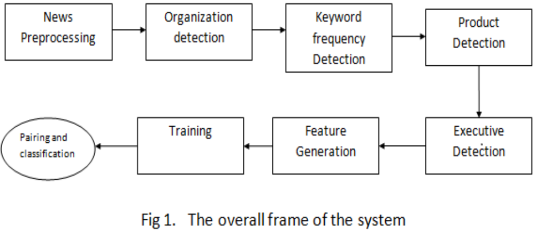

News pre-processor

News from the web is fed to the system as text files which can be generated by a crawler. We did use Nutch crawler in the initial stages of this project but subsequently discarded it because plenty of news was available as plain text on the Web and crawling was not the focus of this paper.

The pre-processor merges all the files into one but defines start/end delimiters for each file in the merged file. The purpose of doing this is to speed up the system because NLP tools like POS tagging and Named Entity Detection take substantial amount of “per file” time for loading. With just one file, the model files for these tools are loaded just once, bringing down the runtime by a factor proportional to the number of news files. The merged news file is acted upon by a log-linear part of speech tagger we obtained from the Stanford NLP webpage.

Organization detection

We follow a three step approach to organization detection:

Step 1. We extract the likely candidates for organization from a POS-tagged version of the merged news file. This is done using regular expressions to detect NNP/NNPS clusters in the POS-tagged file. For example, the pos-tagged version of “General Electric Co”, is “ General_NNP Electric_NNP Co_NNP” which is detected as a likely candidate for an organization.(NNP is one of the tags defined in the penn Treebank tragset which means “Personal Noun” )

Step 2. The candidate names are substantiated by a line of text to aid context based Named Entity De-tection. We have used a Named Entity Recognizer obtained from the Stanford NLP webpage. However, the NER tagger we used is not accurate enough for our task as even a single misclassified organization may lead to wrong pairing. Therefore we follow a frequency based approach.
Our system understands that a single company’s name can occur in many different forms in news. For example, news may talk about “Apple Inc” and then refer to the company as just “Apple”. As another example, consider “Ford Motors Limited”. The same company may be addressed as “Ford Motors”, “Ford Limited” or just “Ford”. Our system takes all such forms as referring to the same company and calculates the total frequency of occurrence of all forms.

Step 3. The organization names are sorted in order of their frequencies and top three organizations are stored for later use. This ensures that even if some names have crept in as organizations due to mis-classification by NER tagger, they end up at the bottom of the list and are discarded.

Multiple Organization Focus: Since we have followed a frequency based approach, the system can do multiple news pairing if the article focuses on more than one organization. To implement this we proceed as follows:
Let f1,f2 be the frequencies of top 2 organizations. Now if f2>f1/2 then the news article is paired with organizations corresponding to both f1 and f2.

Keywords detection

The system matches each news article for occur-rence of a set of keywords like “company”, “share”, “asset”, etc. which have been derived from statistical observation of corporate news. We have used POS tags to differentiate between the contexts in which the keywords have been used. For example, “share” (verb) is not a keyword but “share” (noun) is a keyword. We calculate the net keyword occurrence frequency as N(key)=) where N(key) is the total keyword frequency and is the frequency of each keyword. Net Keyword frequency is used as a primary feature for confirming that the news is of corporate nature.

Headline processing

We process the headline and detect likely candidates for organization names and then cross check with the top 3 organization names detected in the step 2.2. We introduce a new feature h_value described as follows:
Depending on the result of the previous step, if the N(key) >5, then h_value = number of matches that occur in the headline. Otherwise, h_value=0.

Detection of products

The system detects candidates most likely of being products of a company in the news article. This is based on the assumption that a large portion of corporate news generally talks about some product. However, this is not the sole decisive feature of corporate classification and is used as a secondary feature.

We have implemented three empirical rules for product detection

1. NNP followed by _POS followed by _NNP cluster. Ex: Google’s Wave
2. The followed by _NNP cluster. Example: The new POWER7 processors from IBM
3. PRP$ followed by _NNP cluster. Example: Apple announced that its iPhone 3G will not be launched in India.

These rules act on the POS-tagged version of the merged news file. The products are ranked according to the frequency of occurrence and top 3 frequencies are saved for later use.

Executives Detection

Another characteristic feature of corporate news is the direct/indirect speech usage. This speech is generally the statements which the company executives make on behalf of their company. The system attempts to extract the names of executives who find mention in the news article. This is done using a set of rules based on the POS tags of the text. The total frequency of executive names is stored for future use.
Product frequencies and executive frequency are used as secondary features, unlike the keyword count.

Feature Generation

We use a total of 9 features to train the SVM classifier. They are described below:

1-3: frequency of top 3 organizations
4: frequency of Executives in the news article
5-7: frequencies of top 3 products discussed in the news.
8. The N (key) value defined above
9. h value defined above

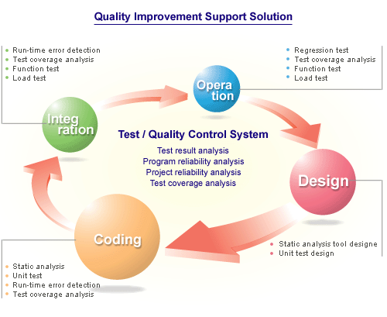

Software and Hardware Requirements
The minimum software and hardware requirements are
Software

Operating System Windows XP Professional (sp2)
Language JAVA (J#.Net)
Data Base Sql Server 2005
IDE Netbeans

Hardware

Processor Pentium-III Intel 80486
Clock speed 800 MHZ or above
Ram 128 MB Ram or above
HDD 20 GB
FDD 1.44 MB

3. SYSTEM DESIGN
Basic Modules

This Project contains totally 2 modules.
Customer
Administrator

- Customer
This module allows defining/registering every new Competitor. It has Company and entity based on the name and news they can access the information

- Admin

This module allows in managing the system and its functioning. This also includes the maintaining of the corporate info.
Data Design
Entity Relationship Diagram
An Entity-Relationship Model (ERM) in software engineering is an abstract and conceptual representation of data. Entity-relationship modeling is a relational schema database modeling method, used to produce a type of conceptual schema or semantic data model of a system, often a relational database, and its requirements in a top-down fashion.
An entity relationship diagram is a graphical representation of an organization’s data storage requirements. Entity relationship diagrams are abstractions of the real world which simplify the problem to be solved while retaining its essential features.

Data Flow Diagrams
A data flow diagram (DFD) is a graphical representation of the "flow" of data through an information system. It differs from the flowchart as it shows the data flow instead of the control flow of the program. A data flow diagram can also be used for the visualization of data processing (structured design).
A flow chart is defined as a pictorial representation describing a process being studied or even used to plan stages of a project. Flow charts tend to provide people with a common language or reference point when dealing with a project or process.
A flowchart is one of the seven basic tools of quality control, which also includes the histogram, Pareto chart; check sheet, control chart, cause-and-effect diagram, and scatter diagram (see Quality Management Glossary). They are commonly used in business/economic presentations to help the audience visualize the content better, or to find flaws in the process.
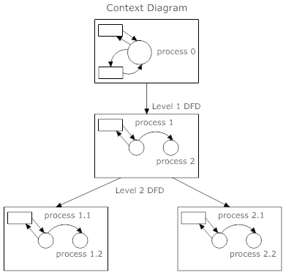
Context Diagram of Level 1 DFD and Level 2 DFD

Sequence Diagrams
A sequence diagram in Unified Modeling Language (UML) is a kind of interaction diagram that shows how processes operate with one another and in what order. It is a construct of a Message Sequence Chart.
Sequence diagrams are sometimes called Event-trace diagrams, event scenarios, and timing diagrams.
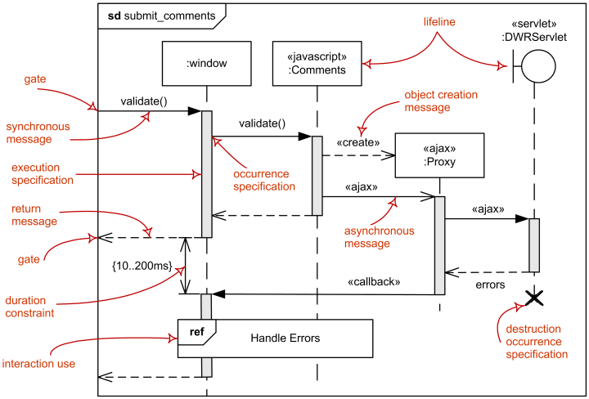

Sequence Diagram Showing use of Nutch crawler

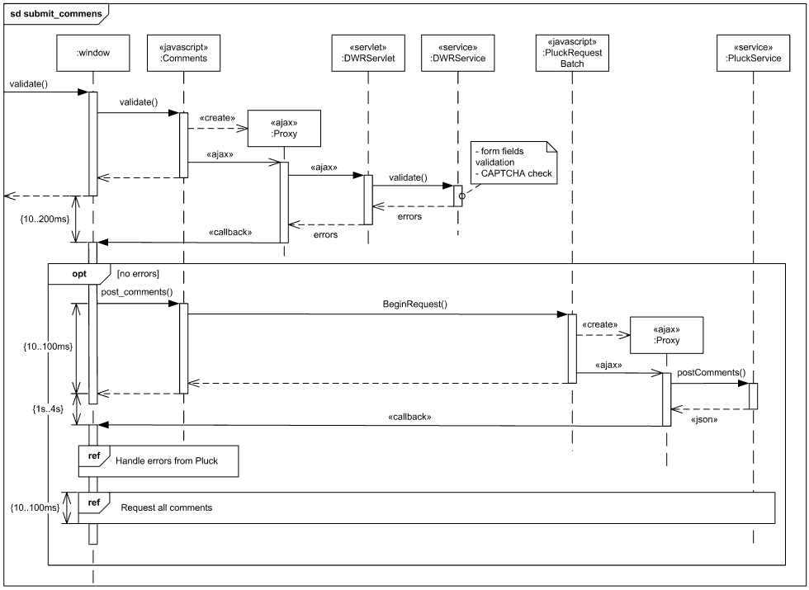

Activity diagrams

Activity Diagrams are a loosely defined diagram technique for showing workflows of stepwise activities and actions, with support for choice, iteration and concurrency. In the Unified Modeling Language, activity diagrams can be used to describe the business and operational step-by-step workflows of components in a system. An activity diagram shows the overall flow of control.

Activity Diagram for Web crawler

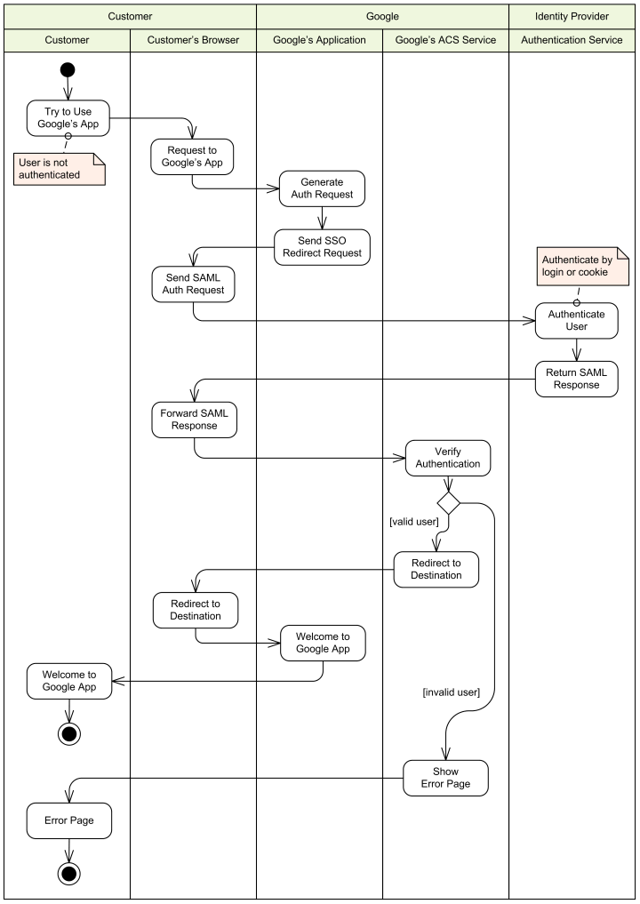

Class Diagram

Class diagram is a type of static structure diagram that describes the structure of a system by showing the system's classes, their attributes, and the relationships between the classes. The UML provide mechanisms to represent class members, such as attributes and methods, and additional information about them. A relationship is a general term covering the specific types of logical connections found on class and objects diagrams.
Class Diagram for POS
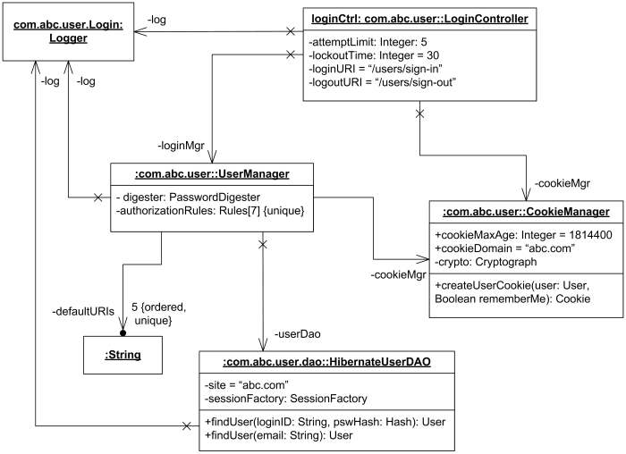

Security Issues
The Information Mining System deals with a lot of proprietary information for its Users, which are confidential. It is therefore imperative to provide a means though which information can be kept confidential. This is also ensures that the data that is put into the system maintains its integrity because malicious or unauthorized individual will not have access to alter them. The security is at administrative level at the project maintenance.
Test Cases Design

Test Type: Login Testing
Test Case: Accept the user information and check whether he is a authenticated user or not
Expected Result: Navigates to the Login Page
Observed Result: Displays the Home

Test Type: Validation Testing
Test Case: Test the status of the project based on checklist id
Expected Result: Data manipulation in database
Observed Result: Done button on the webpage

Test Type: Adding Items to List by Admin
Test Case: Accept the Admin information and enter into the list
Expected Result: Item Added to List
Observed Result: Displays Item in the List

Test Type: Adding Items to Cart by Customer
Test Case: Accept the user information and add it to the cart
Expected Result: Add item in the cart
Observed Result: Displays Item in the cart

SCREEN SHOTS

Code

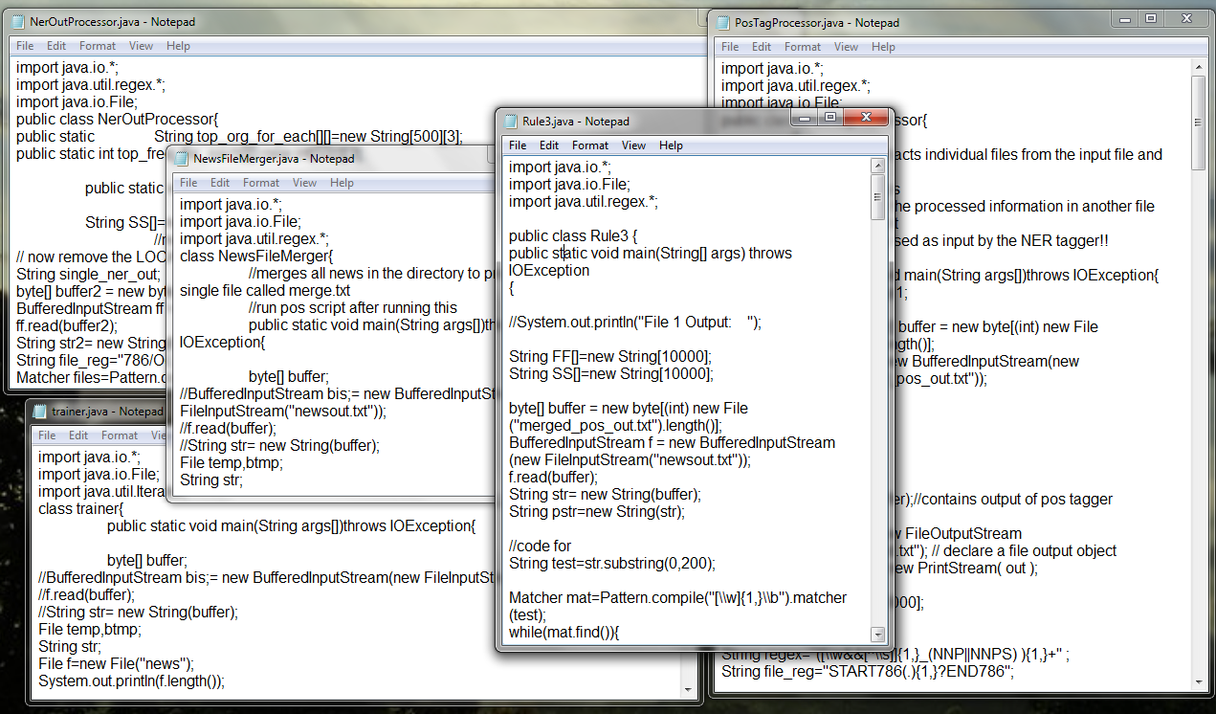

Running on Netbeans IDE

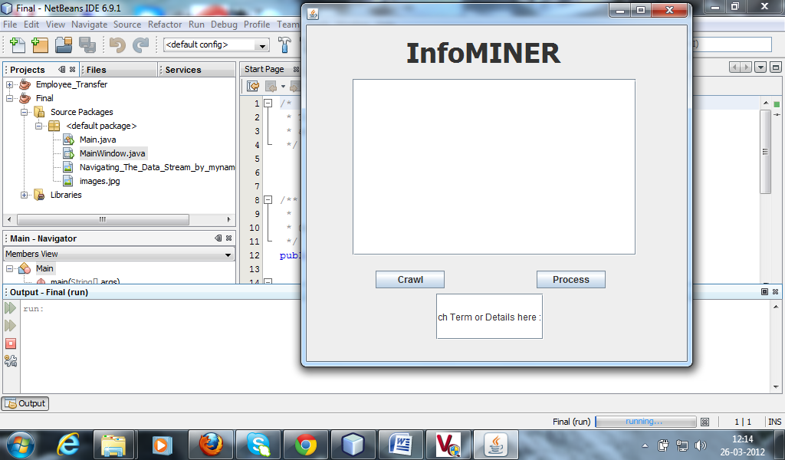

Main class

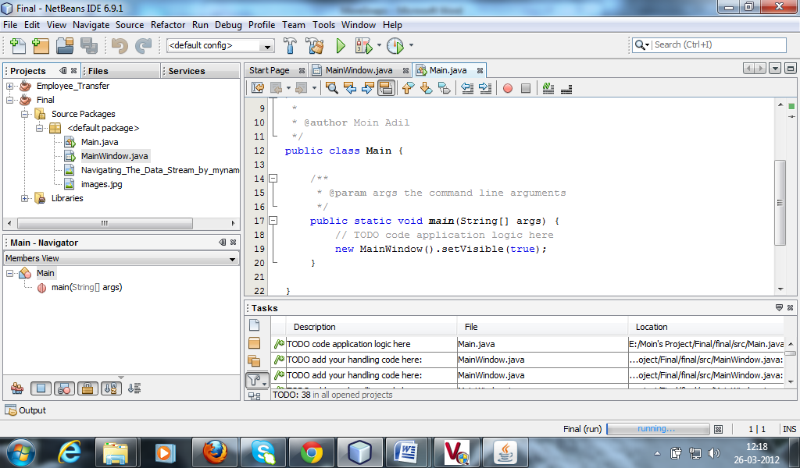

Design View of Main Window

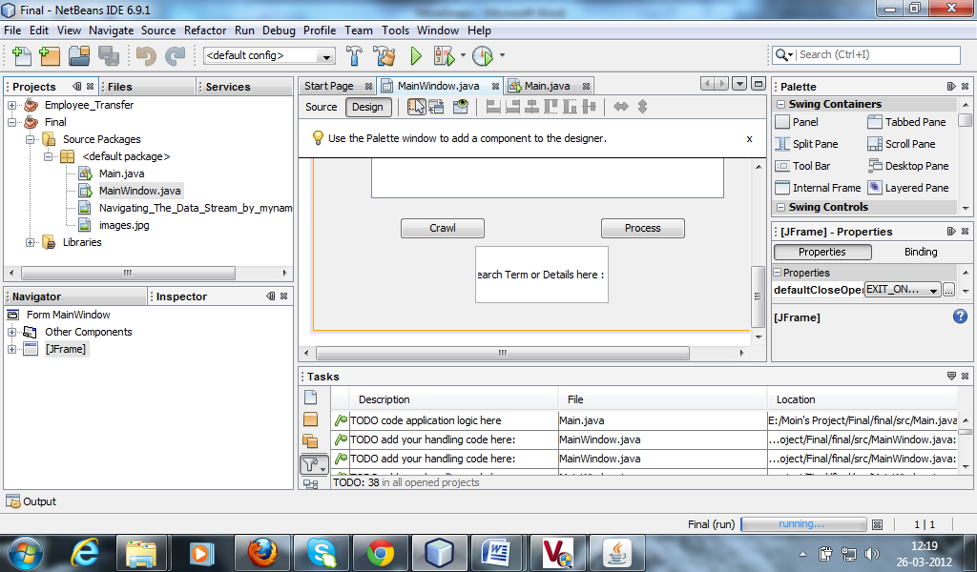

Source View of MainWindow.java

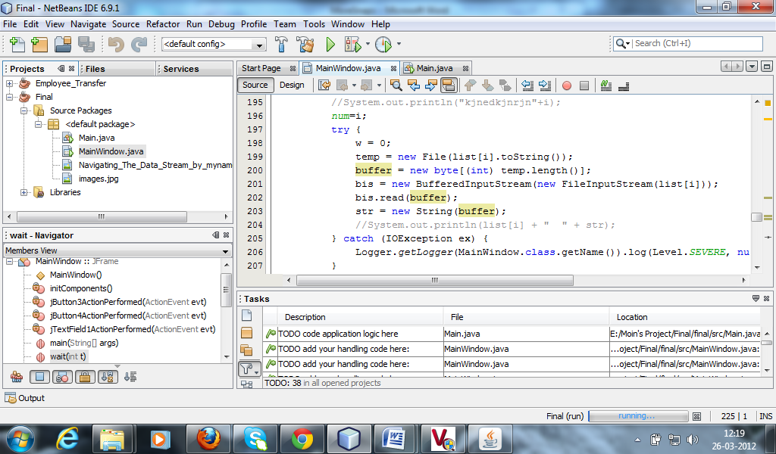

After crawling the news from the INTERNET

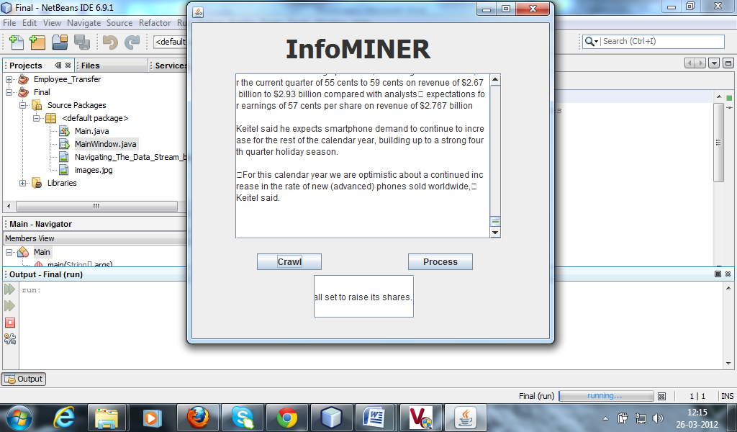

CONSOLE output after running the Info Miner

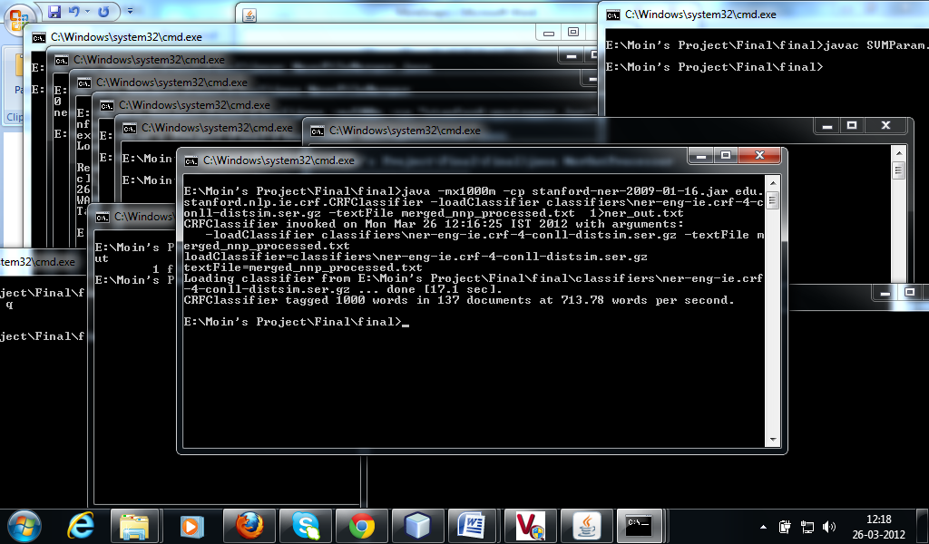

Classification Rules

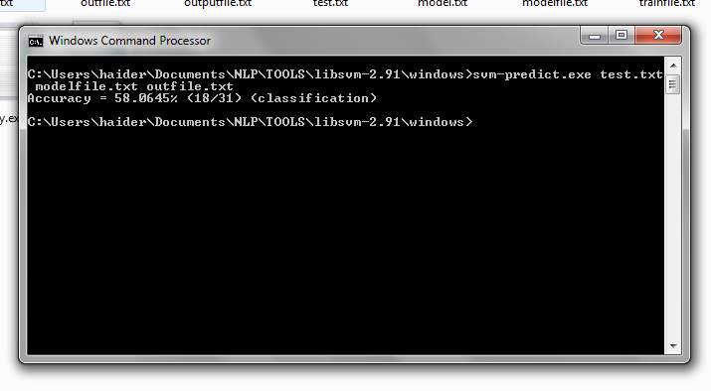
Merged NNP Processed
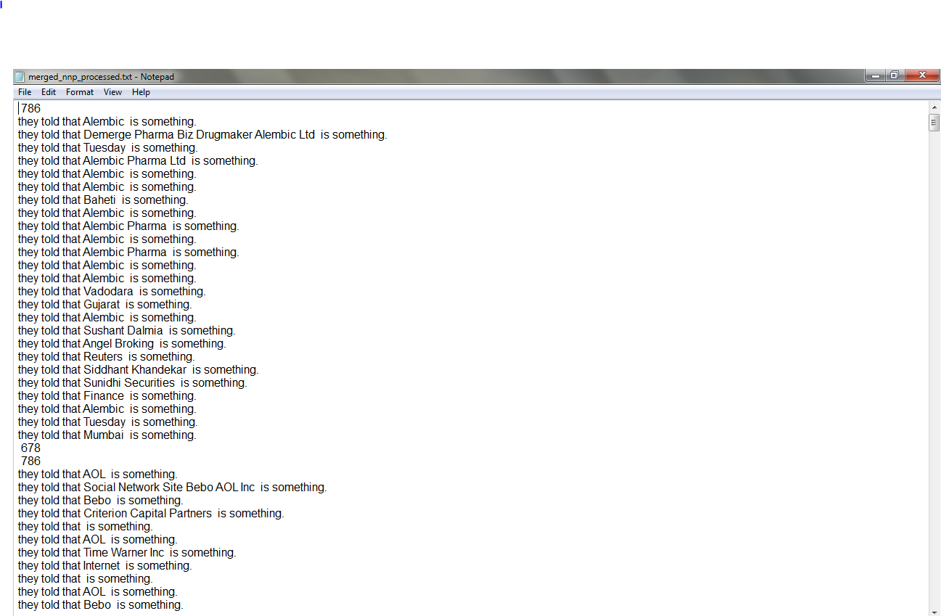
Merged POS

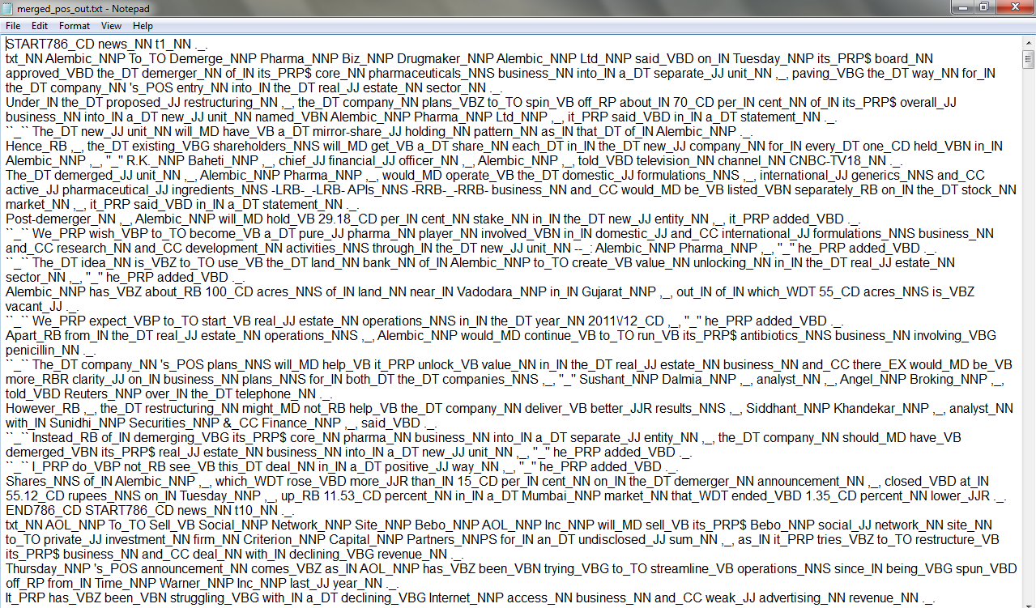

Merge News

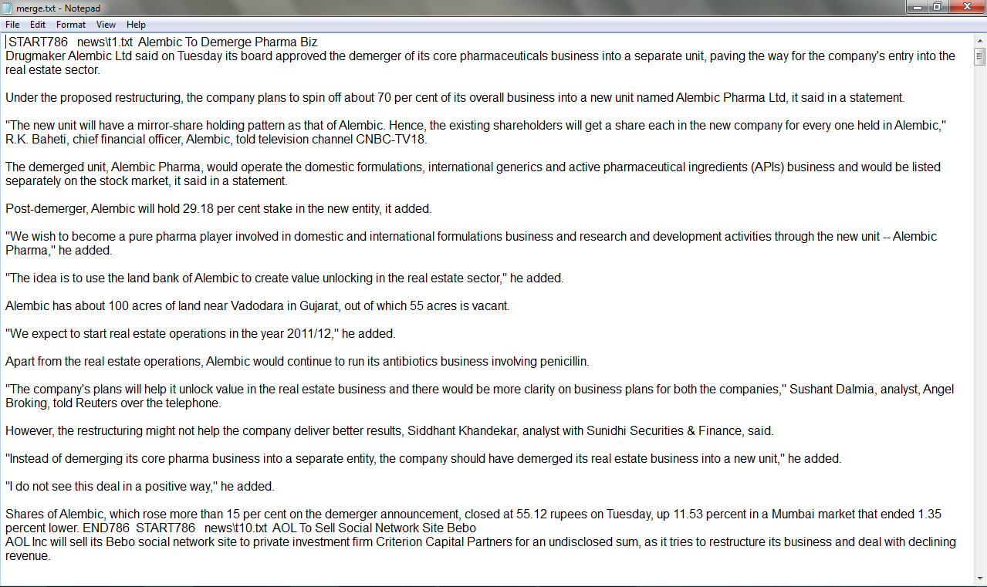
NER output

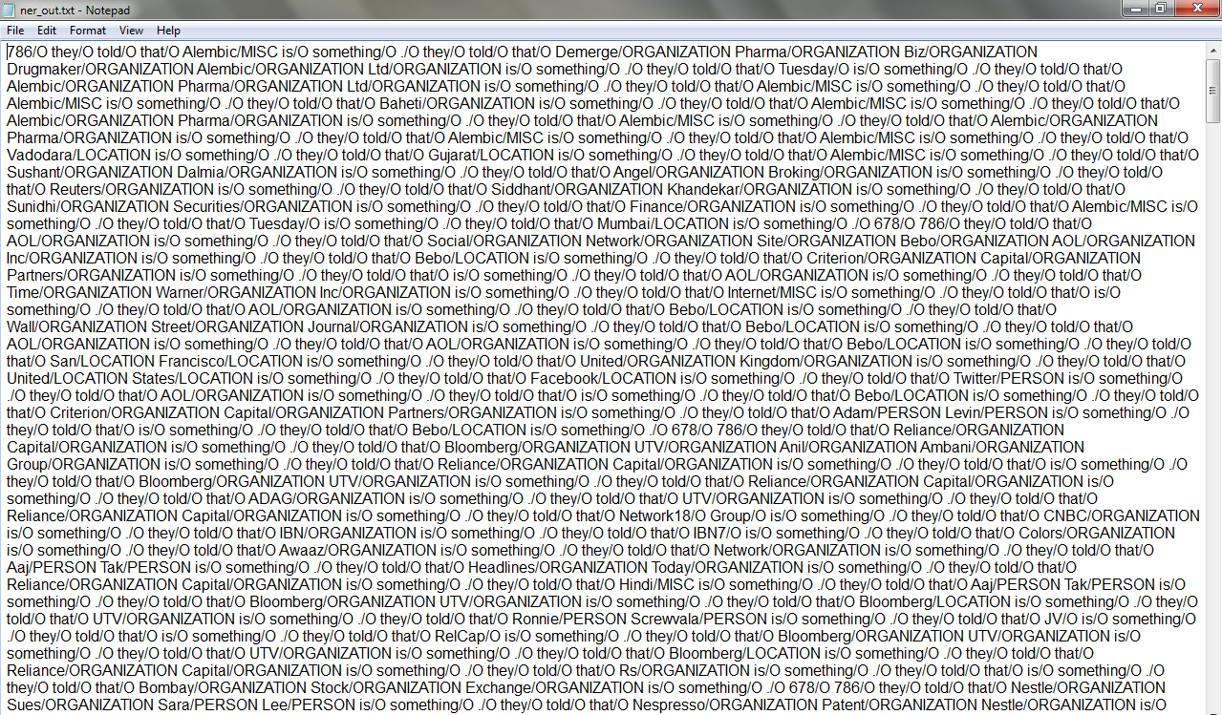
NER output CMD

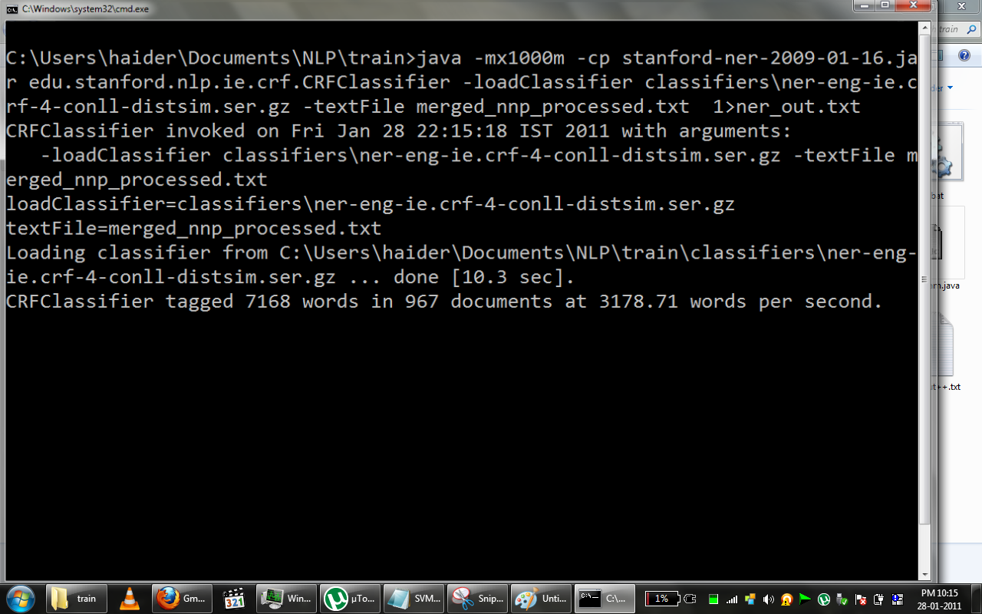

POS output

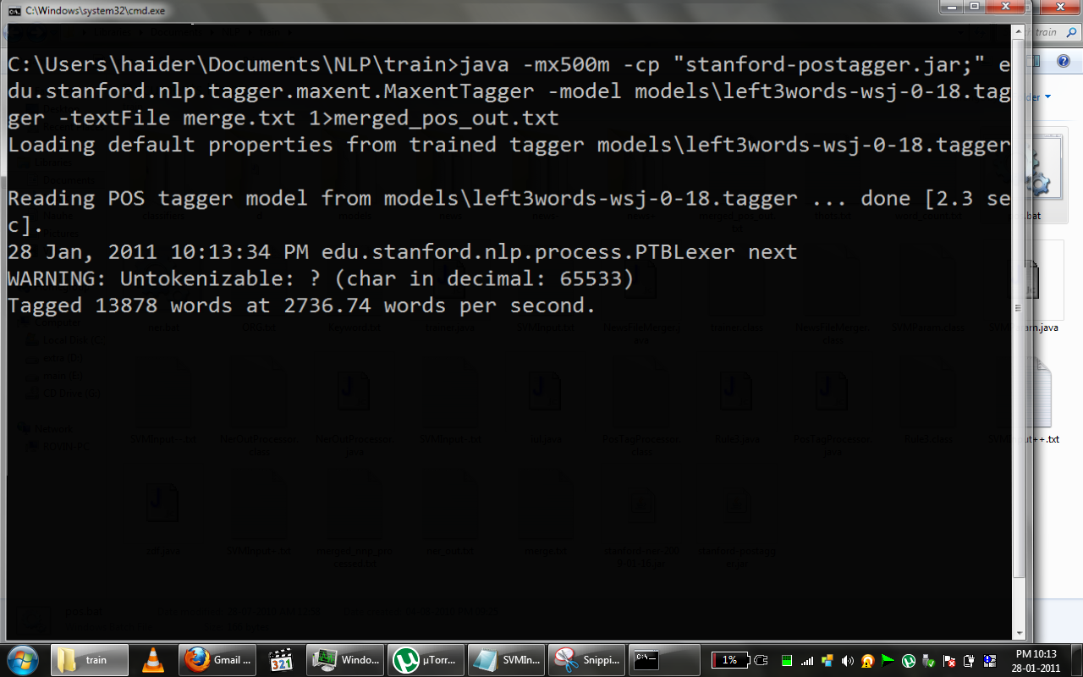

SVM Model File

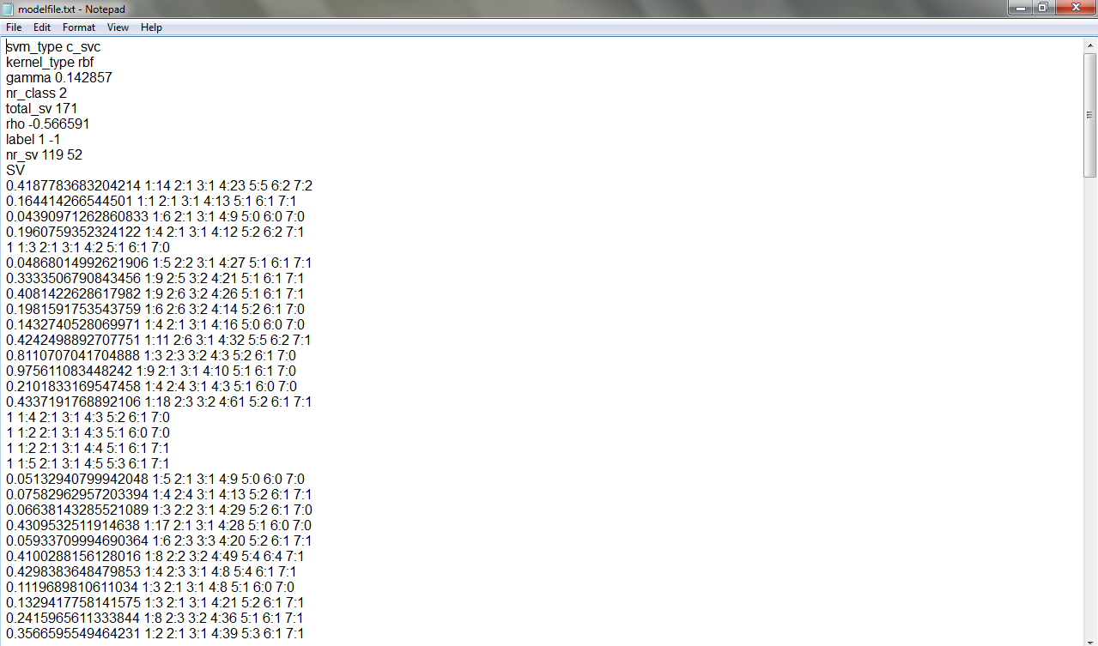

SVM Input File

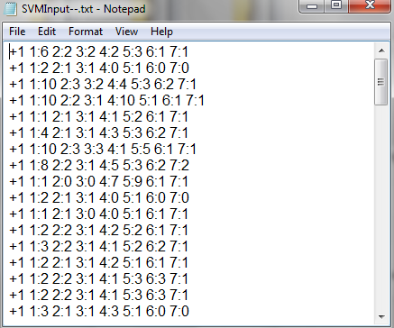

SVM Output File

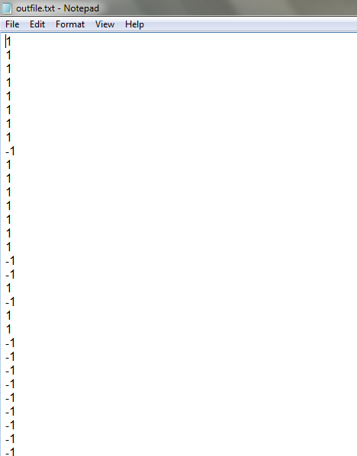

Training Result

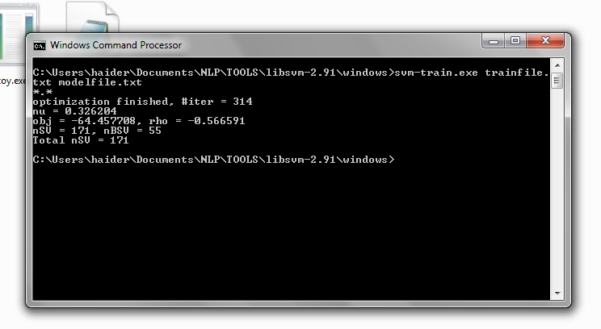

5. CODING
NER_OUT Processor

import java.io.*;
import java.util.regex.*;
import java.io.File;
public class NerOutProcessor{
public static String top_org_for_each[][]=new String[500][3];
public static int top_freq_for_each[][]=new int[500][3];

public static void main(String args[])throws IOException{

String SS[]=new String[10000];
//nw run NER frm cmd...
// now remove the LOCATION from the file output of NER on RUN.TXT
String single_ner_out;
byte[] buffer2 = new byte[(int) new File("ner_out.txt").length()];
BufferedInputStream ff = new BufferedInputStream(new FileInputStream("ner_out.txt"));
ff.read(buffer2);
String str2= new String(buffer2);
String file_reg="786/O(.){1,}?678/O";
Matcher files=Pattern.compile(file_reg,Pattern.DOTALL).matcher(str2);

int fNo=0;

while(files.find()){
single_ner_out=files.group();
//System.out.println(single_file_text);
//mkey=Pattern.compile(regex_key).matcher(str);

String regex3="([A-Z][A-Za-z0-9]{1,}/ORGANIZATION ){1,}";
Matcher m3= Pattern.compile(regex3).matcher(single_ner_out);
int c=0;
while(m3.find())
{
SS[c++]=m3.group();

SS[c-1]=SS[c-1].replaceAll("/ORGANIZATION","");

}

int x=0;
int freq[]=new int[500];
for(;x<500;x++)freq[x]=1;

int i;
for(i=0;i<c;i++){
if(SS[i]=="")continue;

for(int j=i+1;j<c;j++){
if(SS[j]=="")continue;

try{if((SS[i].toLowerCase()).contains(SS[j].toLowerCase())){
SS[j]="";
freq[i]++;

}}
catch(NullPointerException e){
System.out.println("AAARRRGGGGHHHH");
}
}

}

System.out.println("----------------------");
int g=0;
int p1=0;
String org[]=new String[3];//contains top 3 organizations
int max[]=new int[3];max[0]=max[1]=max[2]=0;// max contains freq of top 3 organizations
//String prod[]=new String[3];//contains top 3 prods
//int maxp[]=new int[3];maxp[0]=maxp[1]=maxp[2]=0;// max contains freq of top 3 organizations

for(int l=1;l<=3;l++)
{
for(int k=0;k<c;k++){
if(freq[k]>g){g=freq[k];
max[p1]=freq[k];
org[p1]=SS[k];
freq[k]=0;
}

}g=0;p1++;
}
System.out.println(org[0]+" "+max[0]);
System.out.println(org[1]+" "+max[1]);
System.out.println(org[2]+" "+max[2]);
top_org_for_each[fNo]=org;
top_freq_for_each[fNo++]=max;
//System.out.println(top_freq_for_each[0][0]);

FileOutputStream out; // declare a file output object
PrintStream p; // declare a print stream object

// Create a new file output stream
// connected to "myfile.txt"
out = new FileOutputStream("ORG.txt");

// Connect print stream to the output stream
p = new PrintStream( out );
for(i=0;i<fNo;i++){
p.println ("5:"+top_freq_for_each[i][0]+" 6:"+top_freq_for_each[i][1]+" 7:"+top_freq_for_each[i][2]);
}
p.close();

System.out.print(fNo);
}

}

}

News File Merger

import java.io.*;
import java.io.File;
import java.util.regex.*;
class NewsFileMerger{
//merges all news in the directory to produce a single file called merge.txt
//run pos script after running this
public static void main(String args[])throws IOException{

byte[] buffer;
//BufferedInputStream bis;= new BufferedInputStream(new FileInputStream("newsout.txt"));
//f.read(buffer);
//String str= new String(buffer);
File temp,btmp;
String str;
File f=new File("news");

System.out.println(f.length());
File list[]=f.listFiles();
BufferedInputStream bis;
String wrd_reg="\\b";
Pattern pp=Pattern.compile("\\b");
Matcher m;
FileOutputStream out = new FileOutputStream("merge.txt");
PrintStream p = new PrintStream( out );
out=new FileOutputStream("word_count.txt");
PrintStream p2=new PrintStream(out);
int w;
for(int i=0;i<list.length;i++)
{w=0;
temp=new File(list[i].toString());
buffer= new byte[(int) temp.length()];
bis= new BufferedInputStream(new FileInputStream(list[i]));
bis.read(buffer);
str=new String(buffer);
m=pp.matcher(str);
while(m.find())w++;

p.print(" START786 ");
p.print(" "+list[i]+" ");
p.print(str);
p.print(" END786 ");
System.out.println(list[i]+" "+w/2);
p2.print(w/2+" ");
}
p.close();

}
}

POS Tag Processor

import java.io.*;
import java.util.regex.*;
import java.io.File;
public class PosTagProcessor
{
/*
*This class extracts individual files from the input file and processes them to get
*all NNP-groups
*Then it saves the processed information in another file merged_nnp processed.txt
*which will be used as input by the NER tagger!!
*/
public static void main(String args[])throws IOException
{
int pp1;

byte[] buffer = new byte[(int) new File("merged_pos_out.txt").length()];
BufferedInputStream f = new BufferedInputStream(new FileInputStream("merged_pos_out.txt"));

f.read(buffer);
String str= new String(buffer);//contains output of pos tagger

FileOutputStream out= new FileOutputStream("merged_nnp_processed.txt"); // declare a file output object
PrintStream p= new PrintStream( out );
String pstr;
String FF[]=new String[10000];
//System.out.println(str);

String regex="([\\w&&[^\\s]]{1,}_(NNP||NNPS) ){1,}+" ;
String file_reg="START786(.){1,}?END786";
Matcher files=Pattern.compile(file_reg,Pattern.DOTALL).matcher(str);
Matcher mkey;
Matcher m1;
String single_file_text;
String regex_key;
int fNo=0;
int key[]=new int[500];
String prod[][]=new String[500][3];//contains top 3 prods
int maxp[][]=new int[500][3];//maxp[0]=maxp[1]=maxp[2]=0;// max contains freq of top 3 organizations
int dk=0;
while(files.find()){

single_file_text=files.group();
//System.out.println(single_file_text);
//mkey=Pattern.compile(regex_key).matcher(str);
m1= Pattern.compile(regex).matcher(single_file_text);
//other file String regex_key="[tT]he [Gg]roup|profit|loss|r[oi]se|f[ea]ll| share[s]| facilit|quarter|stake|stock|top_|industr|growth|company|financial|venture|fiscal|corporat|asset";

regex_key="[tT]he_DT [Gg]roup| [Gg]roup_| profit| loss_| r[oi]se_|market| f[ea]ll_|merger_| solution|strateg| facilit|announce|capacity| [Bb]oard | deal_NN |product| share_| [Mm]eeting_| capital_| shares_|acquire|business_|sector| quarter_| stake_| stock_| growth_| company_| top_| industr|financial_| venture_| fiscal_| corporat| major_| asset_| assets_| bid| invest| subsidiary| unit| retail| manufactur| sale";
mkey=Pattern.compile(regex_key).matcher(single_file_text);
pstr=new String(single_file_text);
key[fNo]=0;
while(mkey.find()){
key[fNo]++;
}
fNo++;
int c=0;

while(m1.find())
{
FF[c++]=m1.group();

}

//process the NPPs
for(int i=0;i<c;i++)
{

FF[i]=FF[i].replaceAll("_NNPS","").replaceAll("_NNP","");
//System.out.println(FF[i]);

}
String lists="([Mm]onday)|([Tt]uesday)|([Ww]ednesday)|([Tt]hursday)|([Ff]riday)|([Ss]aturday)|([Ss]unday)|([Ja]anuary)|([ff]ebruary)|([Mm]arch)|([Aa]pril)|([Mm]ay)|([Jj]une)|([Jj]uly)|([Aa]ugust)|([Ss]eptember)|([Oo]ctober)|([Nn]ovember)|([Dd]ecember)|(Crore)|(Arab)|(Million)|(Billion)|(Trillion)|(Thousand)|(Lakh)|(Hundred)|(Jan)|(Feb)|(Mar)|(Apr)|(Jun)|(Jul)|(Aug)|(Sep)|(Sept)|(Oct)|(Nov)|(Dec)";

Matcher lst;
Pattern patt=Pattern.compile(lists);
for(int i=0;i<c;i++) {
lst=patt.matcher(FF[i]);

if(lst.find())FF[i]="";
// System.out.println(b);
}

p.println(" 786 ");
for(int i=0;i<c;i++){p.println("they told that "+FF[i]+" is something.");//System.out.println(FF[i]+"jgjgj");
}
p.println(" 678 ");

//prod code starts here
{

String PP[]=new String[10000];

String regex1_prod="(POS| s_VBZ) ([^ ]{1,} ){0,3}(\\p{Upper}[^ ]{1,}){1,}[^ ]{1,}";//"(POS| s_VBZ)([^_\\p{Upper}]{1,}_){1,4}[^ ]{1,}( \\p{Upper}[^ ]{1,}){1,}[^ ]{1,}";//"(POS| s_VBZ) ([^ ]{1,} ){1,}(\\p{Upper}[^ ]{1,}){1,}[^ ]{1,}";//
String regex2_prod="PRP\\$([A-Za-z\\s]{1,}_NNP){1,}[^_]{1,}";
String regex3_prod="[Tt][Hh][Ee]_DT([^_]{1,}_NNP){1,}([^_]{1,}_NN){0,1}";

Matcher m= Pattern.compile(regex1_prod,Pattern.DOTALL).matcher(pstr);
Matcher m2= Pattern.compile(regex2_prod).matcher(pstr);
Matcher m33=Pattern.compile(regex3_prod).matcher(pstr);
int cc=0;

while(m2.find())
{
PP[cc++]=((m2.group()).toString()).replaceAll("PRP\\$ ","").replaceAll("_NN[PS]{1,2}","").replaceAll(" [a-z]{1,}","");
//System.out.println(PP[cc-1]);
}

while(m.find())
{
PP[cc++]=m.group(3).replaceAll("_[\\w\\W]{1,}","");
//System.out.println(PP[cc-1]);
}
while(m33.find())
{
PP[cc++]=m33.group().replaceAll("[Tt]he_DT ","").replaceAll(" [\\w]{1,}_NN","").replaceAll("_NN[PS]{0,3}","");
//System.out.println(PP[cc-1]);
}

int x=0;
int freq2[][]=new int[500][500];
for(;x<500;x++)freq2[dk][x]=1;

for(int i=0;i<cc;i++){
if(PP[i]=="")continue;

for(int j=i+1;j<cc;j++){
if(PP[j]=="")continue;

try{
if((PP[i].toLowerCase()).contains(PP[j].toLowerCase())){
PP[j]="";
freq2[dk][i]++;

}
}
catch(NullPointerException e){
System.out.println("AAARRRGGGGHHHH");
}
}
}

int g=0;pp1=0;
for(int l=1;l<F=3;l++)
{
for(int k=0;k<cc;k++){
if(freq2[dk][k]>g){g=freq2[dk][k];
maxp[dk][pp1]=freq2[dk][k];
prod[dk][pp1]=PP[k];
freq2[dk][k]=0;
}

}g=0;pp1++;
}dk++;

}
//code block for prod ends

}
p.close();
//for(int i=0;i<fNo;i++)System.out.println("keyword count= "+i+" "+key[i]);
//SENDING keyword freq 2 file
FileOutputStream out1; // declare a file output object
PrintStream p1; // declare a print stream object

// Create a new file output stream
// connected to "myfile.txt"
out1 = new FileOutputStream("Keyword.txt");

// Connect print stream to the output stream
p1 = new PrintStream( out1 );
for(int i=0;i<fNo;i++){
p1.println ("1:"+key[i]+" 2:"+maxp[i][0]+" 3:"+maxp[i][1]+" 4:"+maxp[i][2]);
}
p1.close();

//System.out.println(fNo+" "+dk);

}

}

SVM Param

import java.io.*;
import java.io.File;
import java.util.regex.*;

public class SVMParam {
public static void main(String args[]) throws IOException{
String word_count[]=new String[1000];
byte[] buffer = new byte[(int) new File("ORG.txt").length()];
BufferedInputStream f = new BufferedInputStream(new FileInputStream("ORG.txt"));
f.read(buffer);
String str= new String(buffer);

byte[] buffer1 = new byte[(int) new File("Keyword.txt").length()];
BufferedInputStream f1 = new BufferedInputStream(new FileInputStream("Keyword.txt"));

f1.read(buffer1);
String str1= new String(buffer1);//contains output of pos tagger
Pattern wrd=Pattern.compile("[\\d]{1,} ");
Matcher mwrd;

String regex_org="[\\d]:[\\d]{1,} [\\d]:[\\d]{1,} [\\d]:[\\d]{1,}";
Matcher m=Pattern.compile(regex_org).matcher(str);
int cc=0;
String PP[]=new String[1000];
while(m.find())
{
PP[cc]=m.group();
//PP[cc]=PP[cc].substring(0,PP[cc].lastIndexOf(""));
System.out.println(PP[cc]+" q");
cc++;
}

String regex_keywrd="[\\d]:[\\d]{1,} [\\d]:[\\d]{1,} [\\d]:[\\d]{1,} [\\d]:[\\d]{1,}";
Matcher m2=Pattern.compile(regex_keywrd).matcher(str1);
int ccc=0;
String PPP[]=new String[1000];
while(m2.find())
{
PPP[ccc]=m2.group();
//PP[cc]=PP[cc].substring(0,PP[cc].lastIndexOf(""));
//System.out.println(PPP[ccc]+" q");
ccc++;
}
//System.out.println(cc+" "+ccc);
//now write PP and PPP to a file...final file for SVM
FileOutputStream out1; // declare a file output object
PrintStream p1; // declare a print stream object

// Create a new file output stream
// connected to "myfile.txt"
out1 = new FileOutputStream("SVMInput.txt");

// Connect print stream to the output stream
p1 = new PrintStream( out1 );

buffer = new byte[(int) new File("word_count.txt").length()];
f = new BufferedInputStream(new FileInputStream("word_count.txt"));
f.read(buffer);
str= new String(buffer);
mwrd=wrd.matcher(str);
int wc=0;
String st;
while(mwrd.find()){
word_count[wc]=""+mwrd.group();
System.out.println(word_count[wc]);
wc++;
}
for(int i=0;i<cc;i++){
p1.println (PPP[i]+" "+PP[i]);//word_count[i]);
//else p1.println ("-1 "+PP[i]+" "+PPP[i]);//+" "+"wc"+word_count[i]);
}
p1.close();
}
}

Netbeans main window

import java.io.BufferedInputStream;
import java.io.File;
import java.io.FileInputStream;
import java.io.FileNotFoundException;
import java.io.FileOutputStream;
import java.io.IOException;
import java.io.PrintStream;
import java.util.logging.Level;
import java.util.logging.Logger;
import java.util.Random;
import javax.swing.JOptionPane;

/*
* To change this template, choose Tools | Templates
* and open the template in the editor.
*/

/*
* MainWindow.java
*
* Created on 17 Feb, 2011, 6:27:12 PM
*/
/**
*
* @author Ashish Gupta
*/
public class MainWindow extends javax.swing.JFrame {

/** Creates new form MainWindow */
public static int num=0;
public static String currnews;
public MainWindow() {
initComponents();
}

/** This method is called from within the constructor to
* initialize the form.
* WARNING: Do NOT modify this code. The content of this method is
* always regenerated by the Form Editor.
*/
@SuppressWarnings("unchecked")
// <editor-fold defaultstate="collapsed" desc="Generated Code">
private void initComponents() {

jLayeredPane3 = new javax.swing.JLayeredPane();
jScrollPane2 = new javax.swing.JScrollPane();
jTextArea1 = new javax.swing.JTextArea();
jButton3 = new javax.swing.JButton();
jButton4 = new javax.swing.JButton();
jLabel1 = new javax.swing.JLabel();
jScrollPane1 = new javax.swing.JScrollPane();
jTextArea2 = new javax.swing.JTextArea();

setDefaultCloseOperation(javax.swing.WindowConstants.EXIT_ON_CLOSE);
setBackground(new java.awt.Color(0, 51, 153));
setCursor(new java.awt.Cursor(java.awt.Cursor.DEFAULT_CURSOR));

jTextArea1.setColumns(20);
jTextArea1.setLineWrap(true);
jTextArea1.setRows(5);
jScrollPane2.setViewportView(jTextArea1);

jScrollPane2.setBounds(60, 70, 370, 230);
jLayeredPane3.add(jScrollPane2, javax.swing.JLayeredPane.DEFAULT_LAYER);

jButton3.setText("Crawl");
jButton3.addActionListener(new java.awt.event.ActionListener() {
public void actionPerformed(java.awt.event.ActionEvent evt) {
jButton3ActionPerformed(evt);
}
});
jButton3.setBounds(90, 320, 90, 23);
jLayeredPane3.add(jButton3, javax.swing.JLayeredPane.DEFAULT_LAYER);

jButton4.setText("Process");
jButton4.addActionListener(new java.awt.event.ActionListener() {
public void actionPerformed(java.awt.event.ActionEvent evt) {
jButton4ActionPerformed(evt);
}
});
jButton4.setBounds(300, 320, 90, 23);
jLayeredPane3.add(jButton4, javax.swing.JLayeredPane.DEFAULT_LAYER);

jLabel1.setFont(new java.awt.Font("Tahoma", 1, 36));
jLabel1.setText("InfoMINER");
jLabel1.setBounds(130, 20, 230, 30);
jLayeredPane3.add(jLabel1, javax.swing.JLayeredPane.DEFAULT_LAYER);

jTextArea2.setColumns(20);
jTextArea2.setRows(5);
jScrollPane1.setViewportView(jTextArea2);

jScrollPane1.setBounds(160, 356, 166, 80);
jLayeredPane3.add(jScrollPane1, javax.swing.JLayeredPane.DEFAULT_LAYER);

javax.swing.GroupLayout layout = new javax.swing.GroupLayout(getContentPane());
getContentPane().setLayout(layout);
layout.setHorizontalGroup(
layout.createParallelGroup(javax.swing.GroupLayout.Alignment.LEADING)
.addGroup(layout.createSequentialGroup()
.addComponent(jLayeredPane3, javax.swing.GroupLayout.PREFERRED_SIZE, 484, javax.swing.GroupLayout.PREFERRED_SIZE)
.addContainerGap(javax.swing.GroupLayout.DEFAULT_SIZE, Short.MAX_VALUE))
);
layout.setVerticalGroup(
layout.createParallelGroup(javax.swing.GroupLayout.Alignment.LEADING)
.addComponent(jLayeredPane3, javax.swing.GroupLayout.PREFERRED_SIZE, 438, javax.swing.GroupLayout.PREFERRED_SIZE)
);

pack();
}// </editor-fold>

private void jButton4ActionPerformed(java.awt.event.ActionEvent evt) {
// TODO add your handling code here:
try {
FileOutputStream out = null;
try {
out = new FileOutputStream("C:\\Users\\Shiv and brahma baba\\Desktop\\Final\\final\\news\\n1.txt");
//out = new FileOutputStream("n1.txt");
PrintStream p = new PrintStream(out);
p.print(currnews);
} catch (FileNotFoundException ex) {
Logger.getLogger(MainWindow.class.getName()).log(Level.SEVERE, null, ex);
} finally {
try {
out.close();
} catch (IOException ex) {
Logger.getLogger(MainWindow.class.getName()).log(Level.SEVERE, null, ex);
}
}
//Runtime.getRuntime().exec("cmd /c start javac NewsFileMerger.java"); wait(100);
//Runtime.getRuntime().exec("cmd /c start java NewsFileMerger"); wait(100);
Runtime.getRuntime().exec("cmd /c start batch1.bat");wait(2000000);
Runtime.getRuntime().exec("cmd /c start batch2.bat");wait(2000000);
Runtime.getRuntime().exec("cmd /c start pos.bat");wait(2000000);
Runtime.getRuntime().exec("cmd /c start batch3.bat");wait(2000000);
Runtime.getRuntime().exec("cmd /c start batch4.bat");wait(2000000);
//Runtime.getRuntime().exec("cmd /c start javac PosTagProcessor.java");wait(100);
//Runtime.getRuntime().exec("cmd /c start java PosTagProcessor");wait(100);
Runtime.getRuntime().exec("cmd /c start ner.bat");wait(2000000);
Runtime.getRuntime().exec("cmd /c start batch5.bat");wait(2000000);
Runtime.getRuntime().exec("cmd /c start batch6.bat");wait(2000000);
Runtime.getRuntime().exec("cmd /c start batch7.bat");wait(2000000);
Runtime.getRuntime().exec("cmd /c start batch8.bat");wait(2000000);
//Runtime.getRuntime().exec("cmd /c start batch9.bat");wait(2000000);
Runtime.getRuntime().exec("cmd /c start batch10.bat");wait(2000000);
//Runtime.getRuntime().exec("cmd /c start javac NerOutProcessor.java");wait(100);
//Runtime.getRuntime().exec("cmd /c start java NerOutProcessor");wait(100);
//Runtime.getRuntime().exec("cmd /c start javac SVMParam.java");wait(100);
//Runtime.getRuntime().exec("cmd /c start java SVMParam");wait(100);
String single_ner_out;
byte[] buffer2 = new byte[(int) new File("SVMOut.txt").length()];
BufferedInputStream ff = new BufferedInputStream(new FileInputStream("SVMOut.txt"));
ff.read(buffer2);
String str2= new String(buffer2);
byte[] buffer22 = new byte[(int) new File("ORGname.txt").length()];
BufferedInputStream fff = new BufferedInputStream(new FileInputStream("ORGname.txt"));
fff.read(buffer22);
String str22= new String(buffer22);
System.out.println(str22);

System.out.println("Final="+str2);
//int q=str2.toint();
str2=str2.substring(0,1);
if(str2.equals("1")) jTextArea1.setText("The news article is corporate.");
else jTextArea1.setText("Its not a corporate news article");
} catch (IOException ex) {
Logger.getLogger(MainWindow.class.getName()).log(Level.SEVERE, null, ex);
}

}

private void jButton3ActionPerformed(java.awt.event.ActionEvent evt) {
// TODO add your handling code here:
//byte[] buffer;
//System.out.println("Hello");
//File temp, btmp;
String str = "";
//File f = new File("C:\\Users\\Shiv and brahma baba\\Desktop\\Final\\crawled");
//System.out.println(f.length());
//System.out.println("kjnedkjnrjn");
//File list[] = f.listFiles();
//BufferedInputStream bis;
//int w;
//System.out.println("kjnedkjnrjn");
//for(int i=0;i<list.length;i++)
//int i = 0;

//Random randomGenerator = new Random();
/*int randomInt = randomGenerator.nextInt(list.length);
i=randomInt;
//System.out.println("kjnedkjnrjn"+i);
num=i;
try {
w = 0;
temp = new File(list[i].toString());
buffer = new byte[(int) temp.length()];
bis = new BufferedInputStream(new FileInputStream(list[i]));
bis.read(buffer);
str = new String(buffer);
//System.out.println(list[i] + " " + str);
} catch (IOException ex) {
Logger.getLogger(MainWindow.class.getName()).log(Level.SEVERE, null, ex);
}
*/
//currnews=str;
jTextArea1.setText(jTextArea2.getText());
currnews=jTextArea1.getText();
}

public static void wait(int t)
{
int a=0;
for(int i=0;i<t*100;i++)
{
a++;a--;int y=9;
while(y>0) y--;
}
}

/**
* @param args the command line arguments
*/
public static void main(String args[]) {
java.awt.EventQueue.invokeLater(new Runnable() {

public void run() {
new MainWindow().setVisible(true);
}
});
}
// Variables declaration - do not modify
private javax.swing.JButton jButton3;
private javax.swing.JButton jButton4;
private javax.swing.JLabel jLabel1;
private javax.swing.JLayeredPane jLayeredPane3;
private javax.swing.JScrollPane jScrollPane1;
private javax.swing.JScrollPane jScrollPane2;
private javax.swing.JTextArea jTextArea1;
private javax.swing.JTextArea jTextArea2;
// End of variables declaration
}

6. Testing Apporaches

Software Testing Techniques
Software testing is a critical element of software quality assurance and represents the ultimate review of specification, designing and coding.

Test Case Design
Any engineering product can be tested in one of two ways:

White Box Testing
This testing is also called as glass box testing. In this testing, by knowing the specified function that a product has been designed to perform test can be conducted that demonstrates each function is fully operation at the same time searching for errors in each function. It is a test case design method that uses the control structure of the procedural design to derive test cases. Basis path testing is a white box testing.

Black Box Testing
In this testing by knowing the internal operation of a product, tests can be conducted to ensure that “all gears mesh”, that is the internal operation performs according to specification and all internal components have been adequately exercised. It fundamentally focuses on the functional requirements of the software.
The steps involved in black box test case design are:
- Graph based testing methods
- Equivalence partitioning
- Boundary value analysis
- Comparison testing

Software Testing Strategies
A software testing strategy provides a road map for the software developer. Testing is a set of activities that can be planned in advance and conducted systematically. For this reason a template for software testing a set of steps into which we can place specific test case design methods should be defined for software engineering process. Any software testing strategy should have the following characteristics:
- Testing begins at the module level and works “outward” toward the integration of the entire computer based system.
- Different testing techniques are appropriate at different points in time.
- The developer of the software and an independent test group conducts testing.
- Testing and Debugging are different activities but debugging must be accommodated in any testing strategy.

Unit Testing
Unit testing focuses verification efforts in smallest unit of software design (module).

- Unit test considerations
- Unit test procedures

Integration Testing: Integration testing is a systematic technique for constructing the program structure while conducting tests to uncover errors associated with interfacing. There are two types of integration testing:

- Top-Down Integration: Top down integration is an incremental approach to construction of program structures. Modules are integrated by moving down wards throw the control hierarchy beginning with the main control module.

- Bottom-Up Integration: Bottom up integration as its name implies, begins construction and testing with automatic modules.

- Regression Testing: In this contest of an integration test strategy, regression testing is the re execution of some subset of test that have already been conducted to ensure that changes have not propagate unintended side effects.

Validation Testing:
At the culmination of integration testing, software is completely assembled as a package; interfacing errors have been uncovered and corrected, and a final series of software tests – validation testing may begin. Validation can be fined in many ways, but a simple definition is that validation succeeds when software functions in a manner that can be reasonably expected by the customer.
Reasonable expectation is defined in the software requirement specification – a document that describes all user-visible attributes of the software. The specification contains a section titled “Validation Criteria”. Information contained in that section forms the basis for a validation testing approach.

Validation Test Criteria:
Software validation is achieved through a series of black-box tests that demonstrate conformity with requirement. A test plan outlines the classes of tests to be conducted, and a test procedure defines specific test cases that will be used in an attempt to uncover errors in conformity with requirements. Both the plan and procedure are designed to ensure that all functional requirements are satisfied; all performance requirements are achieved; documentation is correct and human-engineered; and other requirements are met.
After each validation test case has been conducted, one of two possible conditions exists: (1) The function or performance characteristics conform to specification and are accepted, or (2) a deviation from specification is uncovered and a deficiency list is created. Deviation or error discovered at this stage in a project can rarely be corrected prior to scheduled completion. It is often necessary to negotiate with the customer to establish a method for resolving deficiencies.

Alpha and Beta Testing:
It is virtually impossible for a software developer to foresee how the customer will really use a program. Instructions for use may be misinterpreted; strange combination of data may be regularly used; and output that seemed clear to the tester may be unintelligible to a user in the field.
When custom software is built for one customer, a series of acceptance tests are conducted to enable the customer to validate all requirements. Conducted by the end user rather than the system developer, an acceptance test can range from an informal “test drive” to a planned and systematically executed series of tests. In fact, acceptance testing can be conducted over a period of weeks or months, thereby uncovering cumulative errors that might degrade the system over time.
If software is developed as a product to be used by many customers, it is impractical to perform formal acceptance tests with each one. Most software product builders use a process called alpha and beta testing to uncover errors that only the end user seems able to find.
A customer conducts the alpha test at the developer’s site. The software is used in a natural setting with the developer “looking over the shoulder” of the user and recording errors and usage problems. Alpha tests are conducted in controlled environment.
The beta test is conducted at one or more customer sites by the end user of the software. Unlike alpha testing, the developer is generally not present. Therefore, the beta test is a “live” application of the software in an environment that cannot be controlled by the developer. The customer records all problems that are encountered during beta testing and reports these to the developer at regular intervals. As a result of problems reported during bets test, the software developer makes modification and then prepares for release of the software product to the entire customer base.

7. FEATURES
It highlights a type of information retrieval whose goal is to automatically extract structured information from unstructured machine-readable documents. Information extraction differs from information retrieval, in that the focus is not upon finding documents but upon finding useful information inside documents. Typically, texts in an electronic document feed are examined to see if they contain certain target terms, and therefore merit further analysis.
Linguists may use a web crawler to perform a textual analysis; that is, they may comb the Internet to determine what words are commonly used today. Market researchers may use a web crawler to determine and assess trends in a given market. There are numerous nefarious uses of web crawlers as well. In the end, a web crawler may be used by anyone seeking to collect information out on the Internet.
Web crawling is an important method for collecting data on, and keeping up with, the rapidly expanding Internet. A vast number of web pages are continually being added every day, and information is constantly changing. A web crawler is a way for the search engines and other users to regularly ensure that their databases are up to date.
A major focus of machine learning research is to automatically learn to recognize complex patterns and make intelligent decisions based on data; the difficulty lies in the fact that the set of all possible behaviors given all possible inputs is too complex to describe generally in programming languages, so that in effect programs must automatically describe programs.
Support vector machines (SVMs) are a set of related supervised learning methods used for classification and regression. In simple words, given a set of training examples, each marked as belonging to one of two categories, an SVM training algorithm builds a model that predicts whether a new example falls into one category or the other.
Support Vector Machine (SVM) models are a close cousin to classical multilayer perceptron neural networks. Using a kernel function, SVM’s are an alternative training method for polynomial, radial basis function and multi-layer perceptron classifiers in which the weights of the network are found by solving a quadratic programming problem with linear constraints, rather than by solving a non-convex, unconstrained minimization problem as in standard neural network training.
Support Vector Machine (SVM) models are a close cousin to classical multilayer perceptron neural networks. Using a kernel function, SVM’s are an alternative training method for polynomial, radial basis function and multi-layer perceptron classifiers in which the weights of the network are found by solving a quadratic programming problem with linear constraints, rather than by solving a non-convex, unconstrained minimization problem as in standard neural network training.
.

User friendly
This project provides very simple and modified features, which are very easy to view and operate. This project is designed and organized in a very simplified manner to hold the details of projects of any firm and also the details of news merging who are haired to do this project.
Other Features
- Web Crawler
- Support Vector Machine Usage
- Fast Processing
- NLP implementation with Java
- Automated Searching
- Completely hosted for Clients

8. Future Scope of the Project

This project “Information Mining System” gives scope for further enhancement. To this project some features in further advancements.
This project can be used by large organizations where they want to classify/separate corporate news from non-corporate news. By this way they will be able to gain corporate news and thus they know that this is the useful information. Now, further this information can be used to detect whatever opinion people have given about the products of that organization so that this information can be used to enhance their product quality.
Further, the information can be used to track the rival organization’s product or their related news. By this way the organization can keep enhancing their product and update their information so as to take the organization to higher levels.
Moreover, NLP techniques were discussed to better the existing methodology for News-Company pairing.
This system can be further enhanced so as to classify the given misclassified news correctly and to train the system with more and more training examples and increase the features so as to get more refined system.

9. CONCLUSION

The project titled as “Information Mining System” was deeply studied and analyzed to design the code and implement with various testing methods was done under the guidance of the experienced project guide. The solution developed is free from all the bugs and executable with all different modules to the utmost satisfaction of the client. All the current requirements and possibilities have been taken care during the project time. We feel that the solution provided now will suit to all the needs of various clients in the same industry but also we don’t rule the possibilities of further upgrading of this solution with the new and advance technologies and further additional requirements of the clients.

The documentation and the project report are finally prepared to be referred as user manual for further effective results of this software solution. Now the project is completed and ready to submit to the head of the department of the college for further process.

